

**INDIVIDUAL ASSIGNMENT**

**TECHNOLOGY PARK MALAYSIA**

**CT010-3-1-FSD**

**FUNDAMENTALS OF SOFTWARE DEVELOPMENT**

**NAME : TAN ZE KAI**

**TP NUMBER : TP 061463**

**INTAKE CODE : APU1F2006CS (IS)**

**HAND OUT DATE: 17TH AUGUST 2020**

**HAND IN DATE: 20TH SEPTEMBER 2020**

**WEIGHTAGE: 100%**

**INSTRUCTIONS TO CANDIDATES:**

1. Submit your assignment online in MS Teams unless advised otherwise
2. Late submission will be awarded zero (0) unless Extenuating Circumstances (EC) are upheld
3. Cases of plagiarism will be penalized
4. You must obtain at least 50% in each component to pass this module

Table of Contents

INTRODUCTION 4

ASSUMPTION 4

Design of Program 5

Pseudocode 5

Ware houses 5

Categorising Parts to Section 6

Update Part’s Amount 8

Supplier Info 11

Print Warehouse Parts Record 12

Print Sections’ Parts and Amount 13

14

Print ITEM which is below 10 14

Menu Function 17

Flow Chart 21

Warehouses 21

Parts in respective section 22

23

Update Parts’ Amount 23

29

Record Supplier Supplied More Than One Part 29

Print Warehouse Records 30

30

30

Print items that are below 10 30

Print Section’s Parts & Amount 31

31

Search Function 31

31

32

41

Program Source Code Explanation 43

Screen Shot of input and output 45

Conclusion 55

References 55

# INTRODUCTION

Volkswagen Wolfsburg Plan which is one of the automobile manufacturing plant. It produces different models of passenger cars in different places. There are various models that have been producing which are Volkswagen Golf, Volkswagen Golf R04, Volkswagen Golf GTI03 (Enrico, 2018) and many.

Unfortunately, our manufacture was under a poor economic situation and the company had decided to produce a new model of car with a variety of divisions from each and every of the car model to overcome this serious issue. Therefore, the manufacture has been collecting different models of cars storing in three different warehouses. In each of the warehouses, there are five types of parts which are the Gear Box, Clutch, Multi-Cylinder Engine, Air-Cooled Engine and Steering assembling under three different section, engine section, transmission section and body section.

# ASSUMPTION

As creating a new model of car, there are five main components only needed. All of the parts are supplied by three various suppliers who are ZF Lenksysteme, Blaupunkt and Volksawagen Group supplying to three warehouses named vGolf, vGolf_R and vGolf_G. The parts in vGolf are Gear Box (GBV1), Clutch (CV2), Multi-Cylinder Engine (MCEV3), Air-Cooled Engine (ACEV4), Steering (SV5) while there are Gear Box_R (GBVR1), Clutch_R (CVR2), Multi-Cylinder_R Engine (MCEVR3), Air-Cooled_R Engine (ACEVR4) and Steering_R (SVR5) in vGolf_R. Lastly, vGolf_G contained Gear Box_G (GBVG1), Clutch_G (CV2),Multi-Cylinder_G Engine (MCEVG3), Air-Cooled_G Engine (ACEVG4) and Steering_G (SVG5). Thus, all the quantities including those have been collecting and new parts supplied by suppliers are recording in the program.

# Design of Program

## Pseudocode

### Ware houses

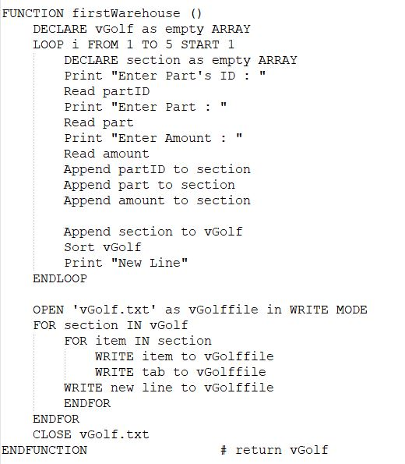

Figure 1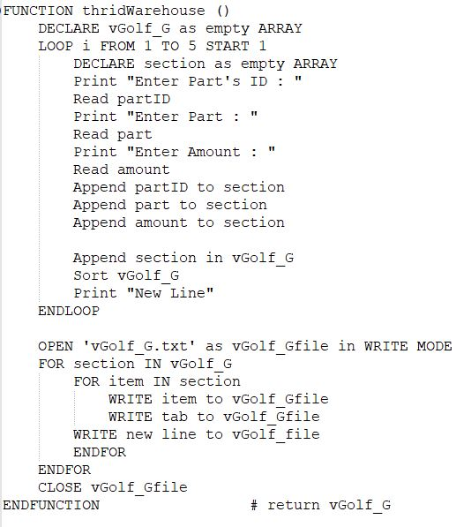

### Categorising Parts to Section

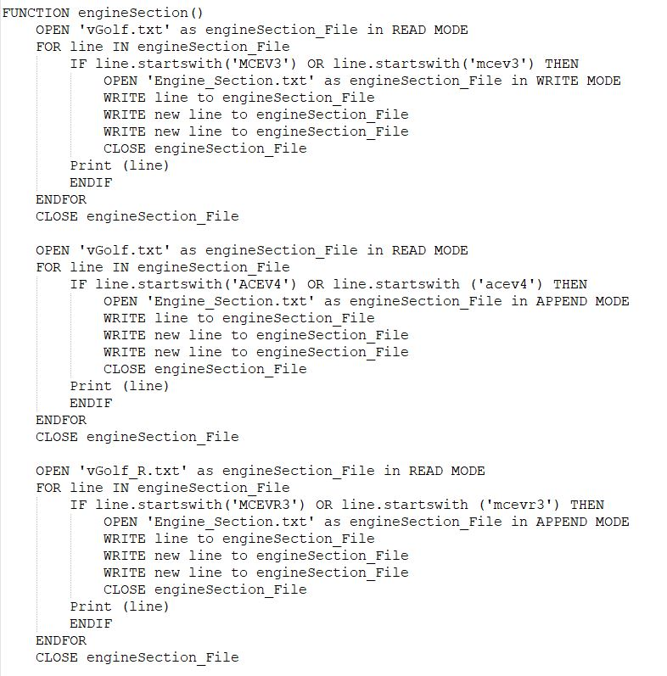

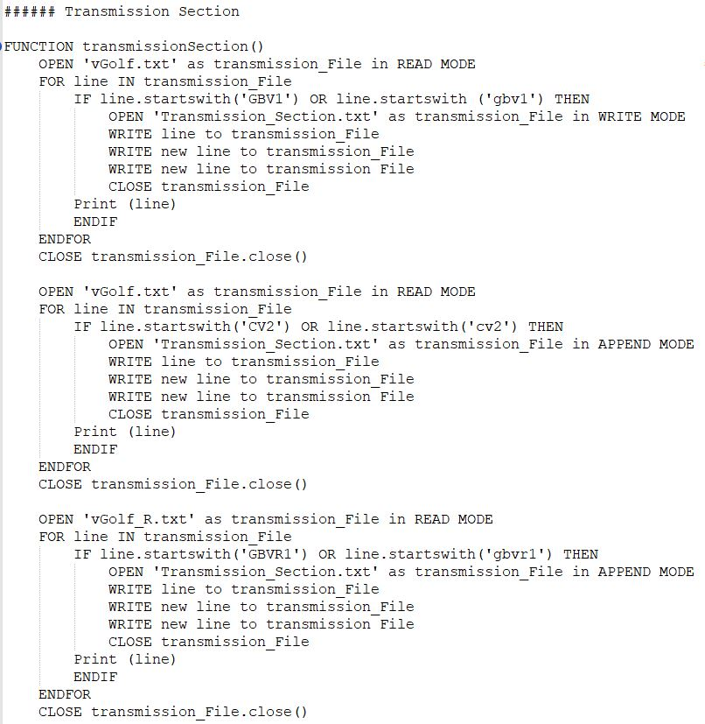

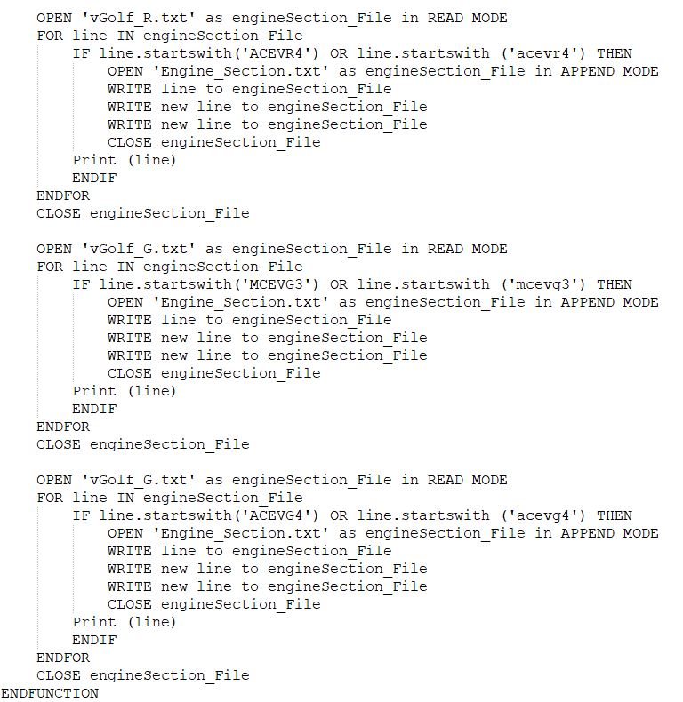

Figure 2.1

Figure 3

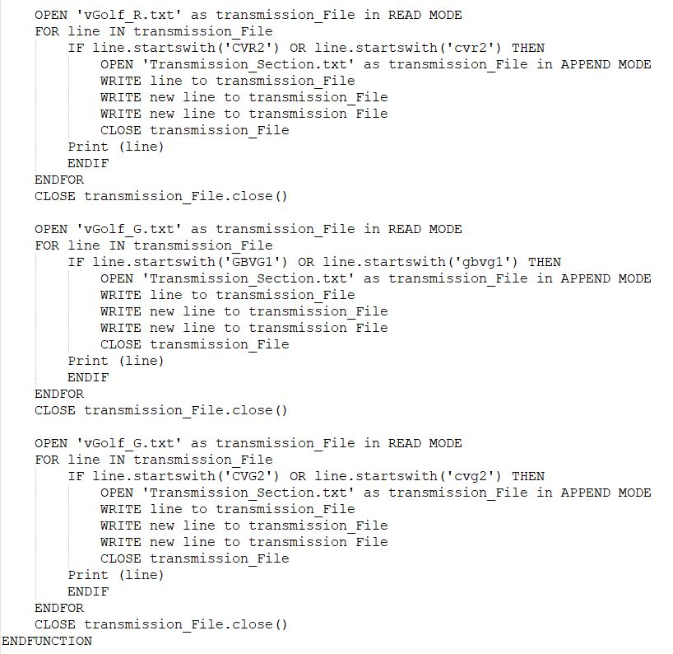

Figure 2

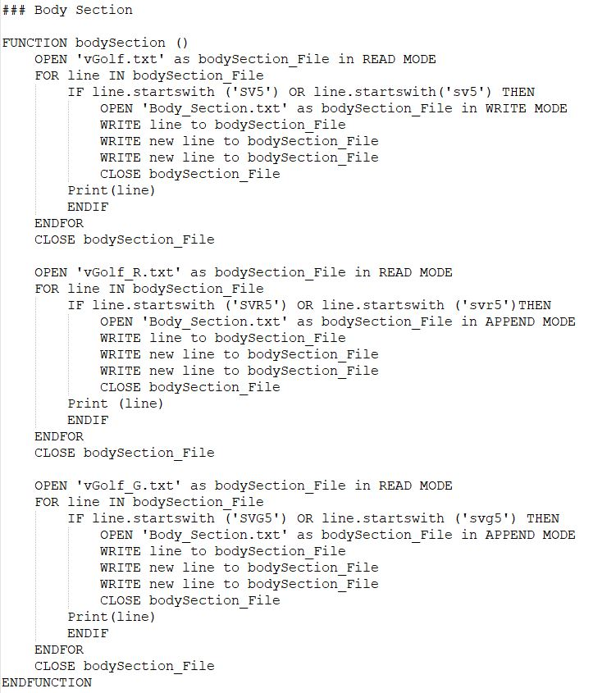

Figure 4

### Update Part’s Amount

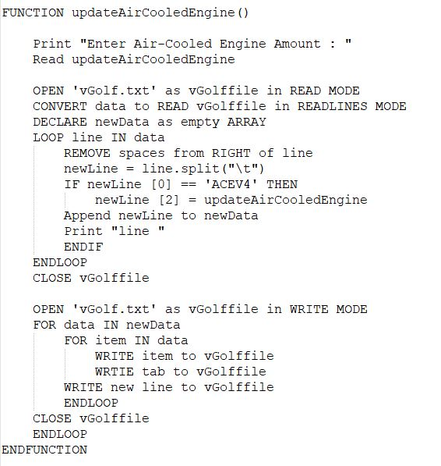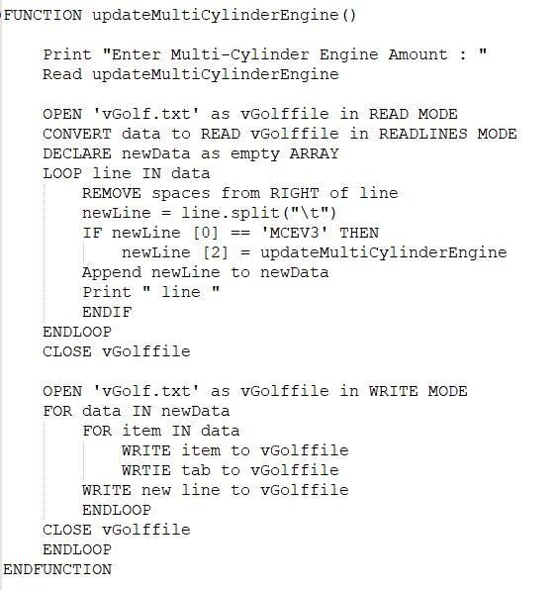

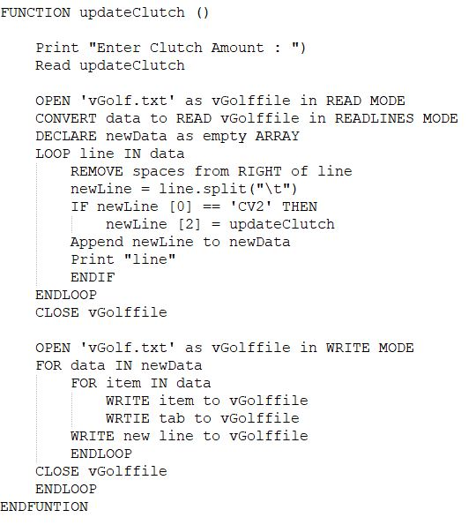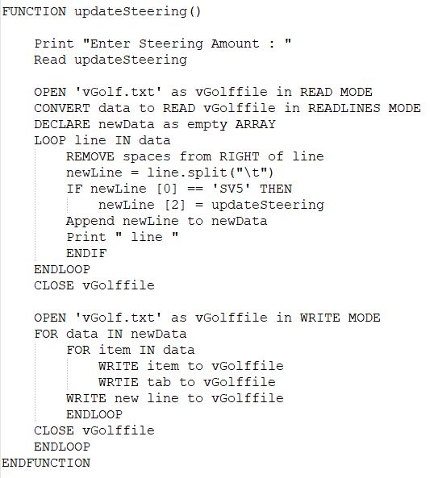

Figure 5

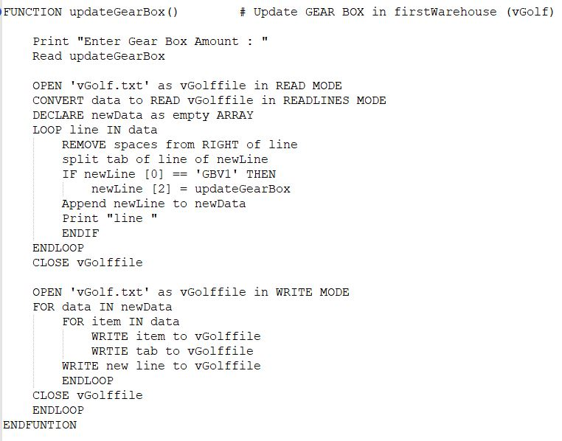

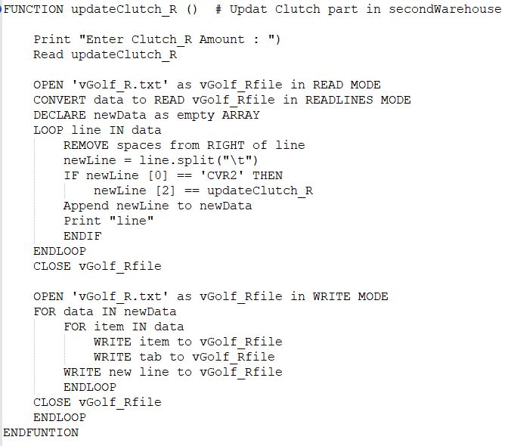

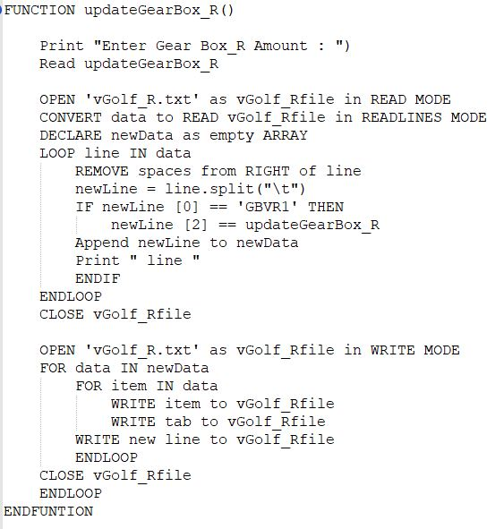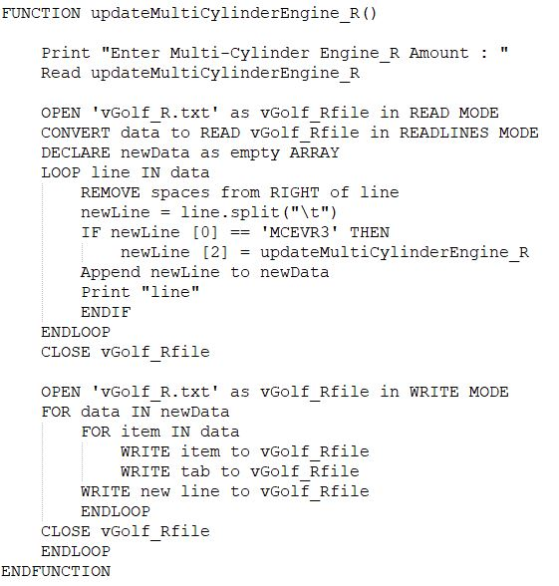 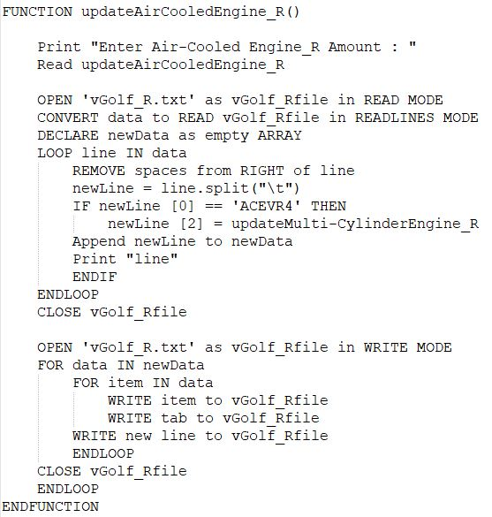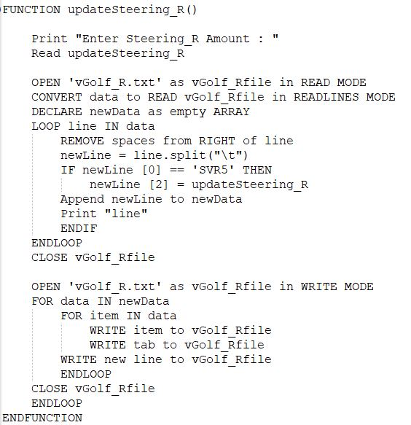

Figure 6

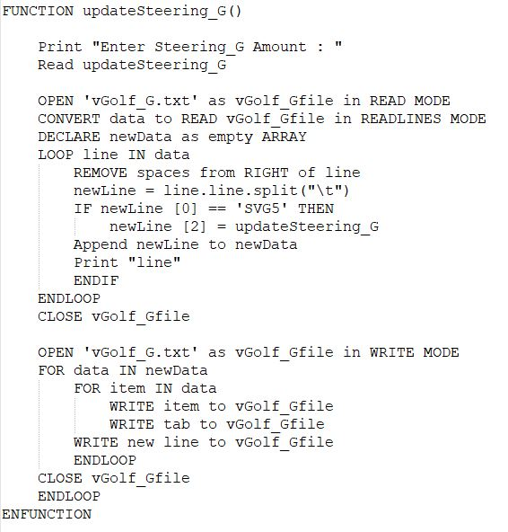

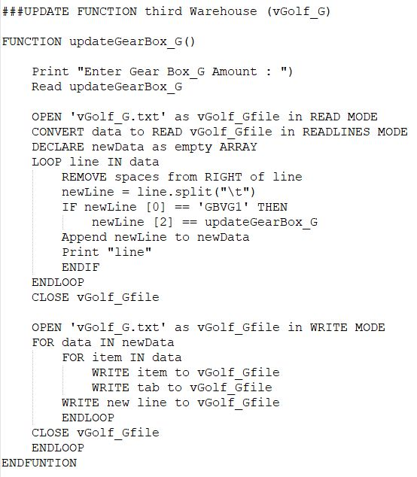

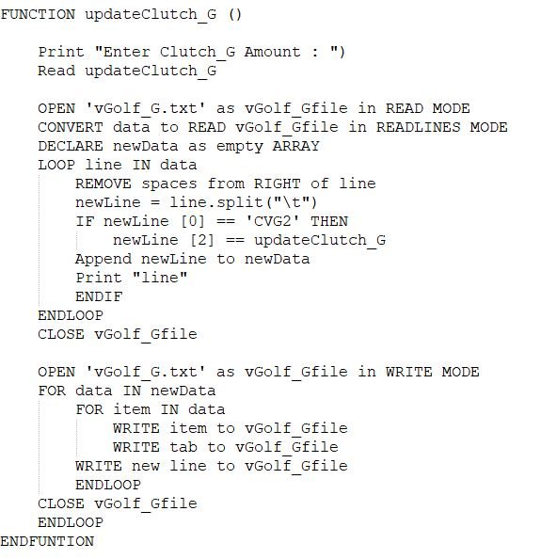

Figure 7

### Supplier Info

Figure 8

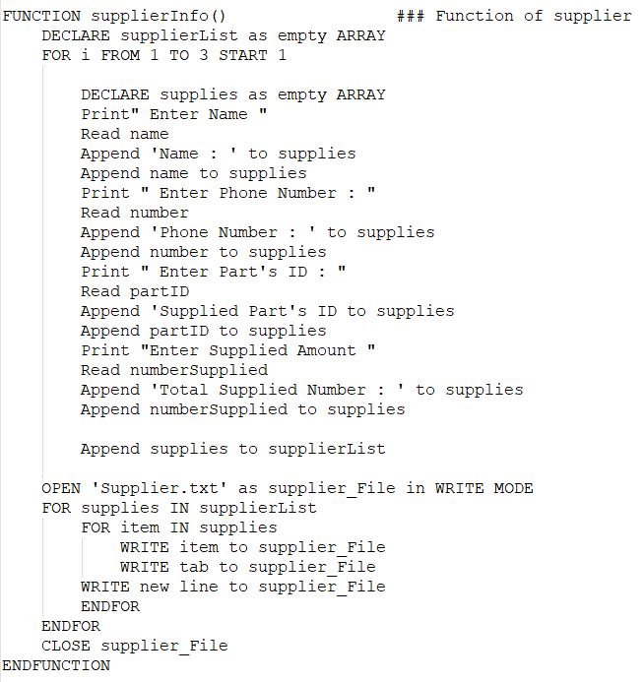

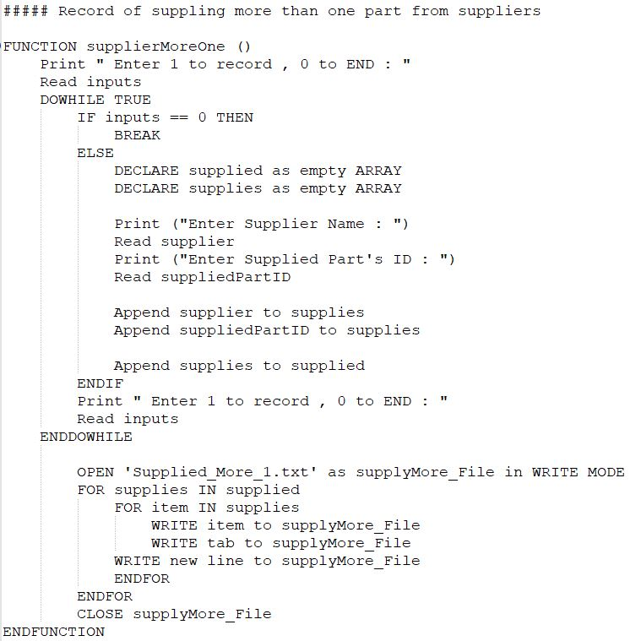

### Print Warehouse Parts Record

Figure 9

### Print Sections’ Parts and Amount

Figure 10

### 

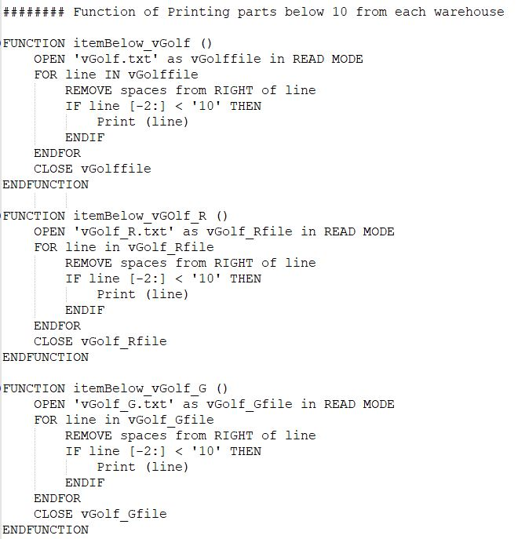Print ITEM which is below 10 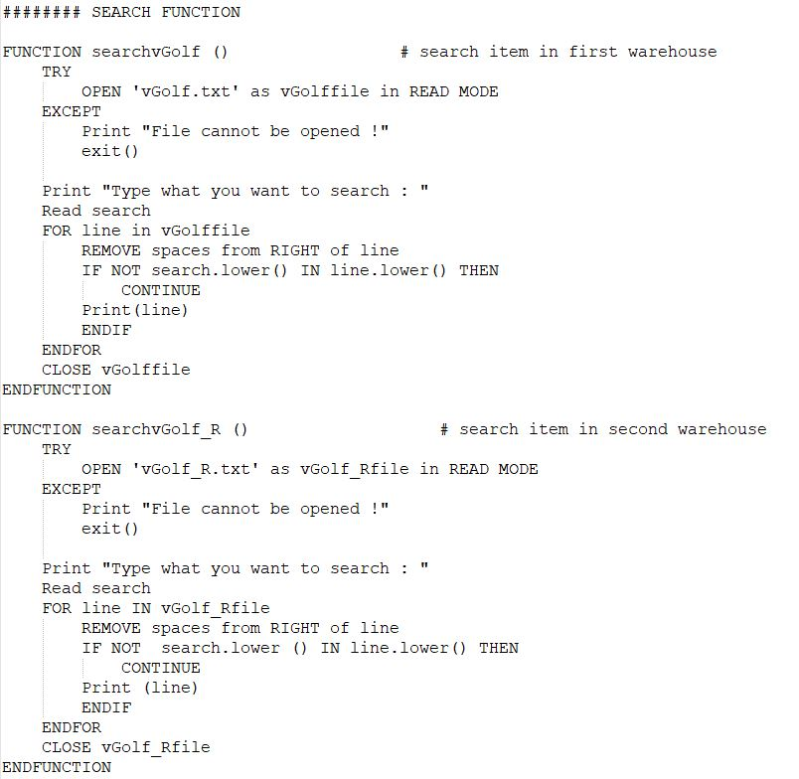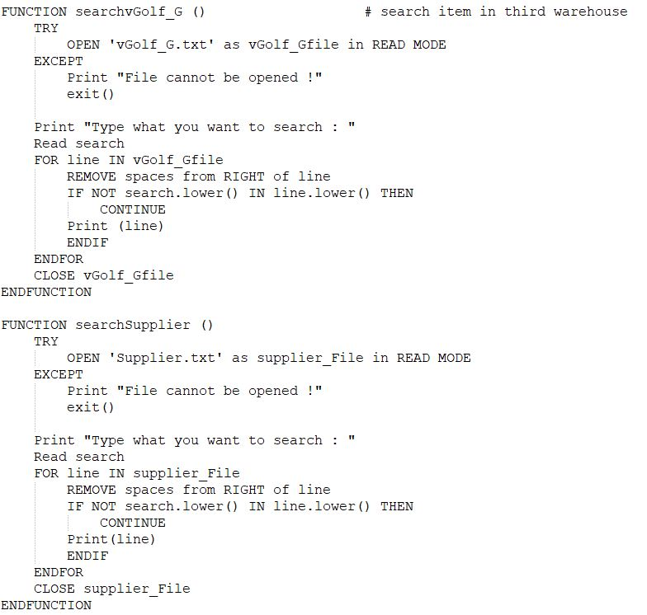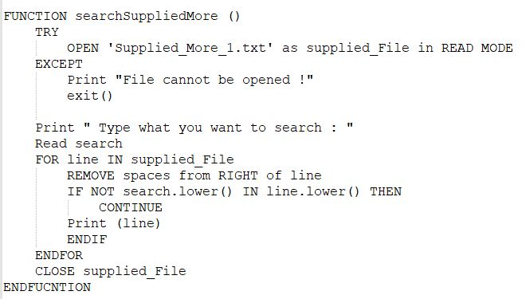Search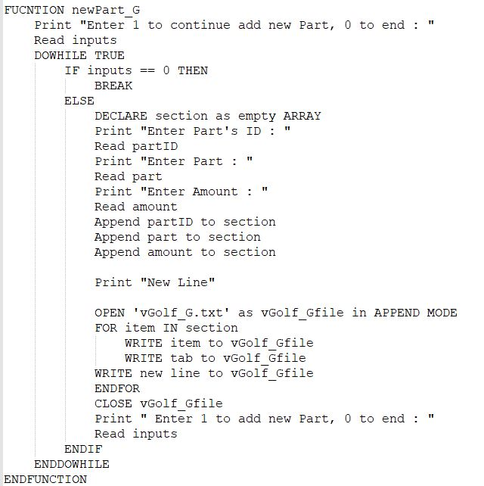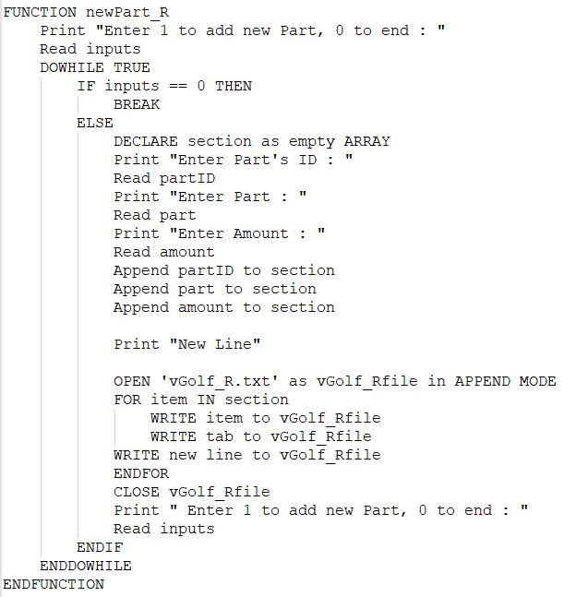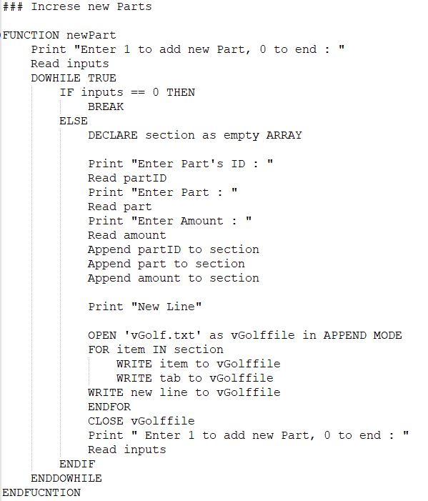Increasing Part’s Amount

Figure 11

Figure 12

Figure 13

### Menu Function

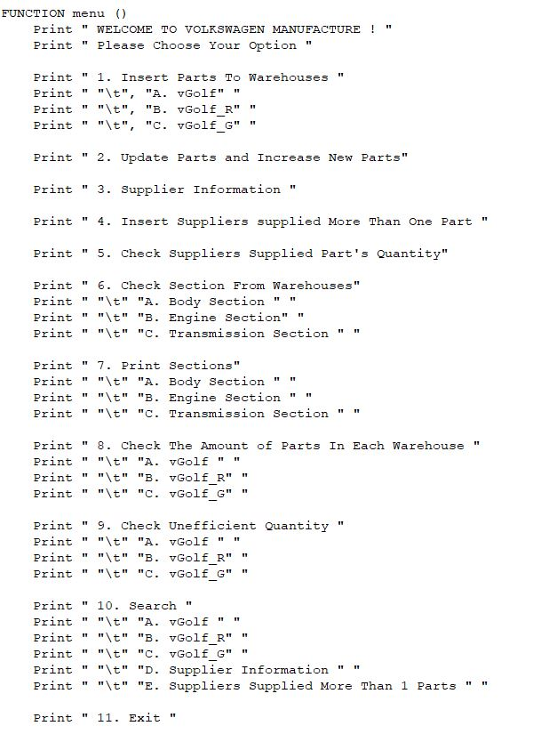

Figure

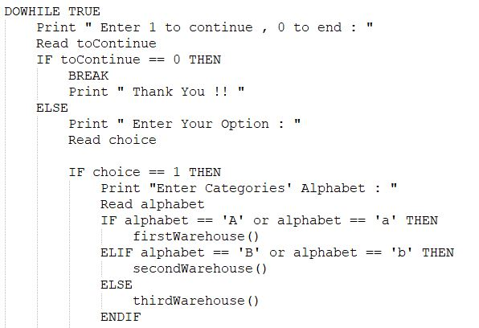



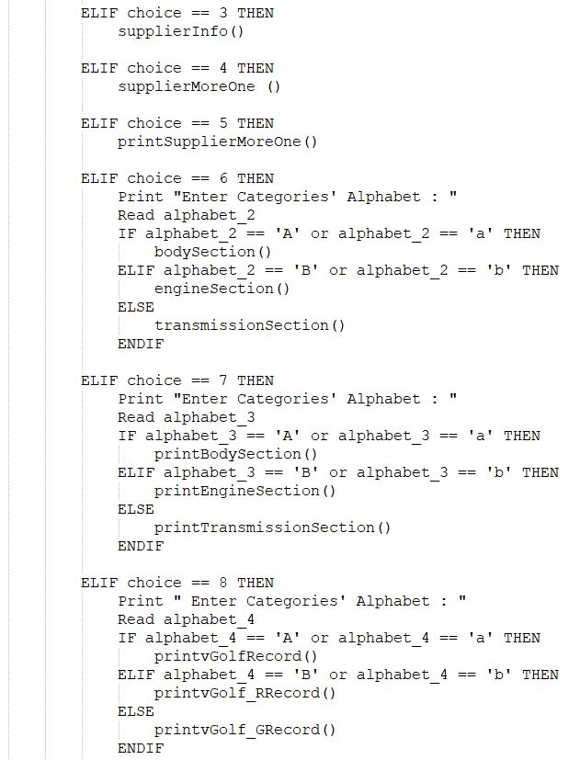

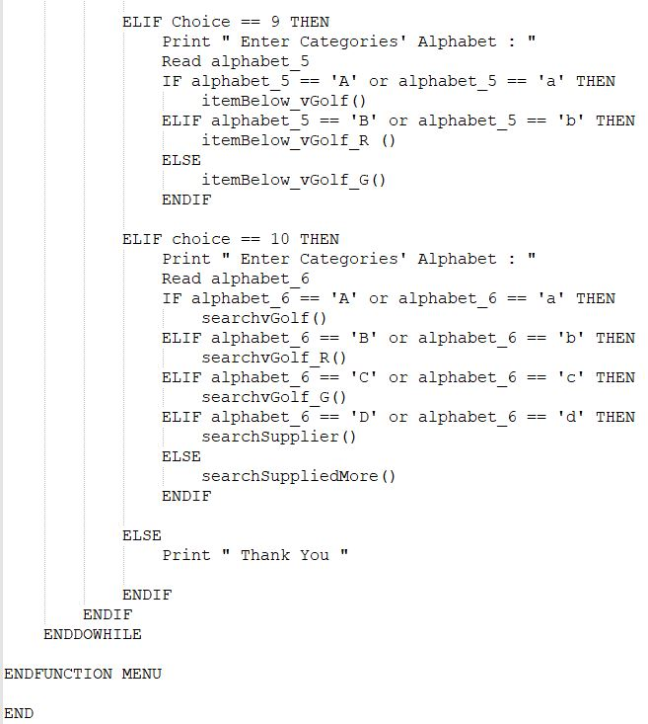

Figure 15

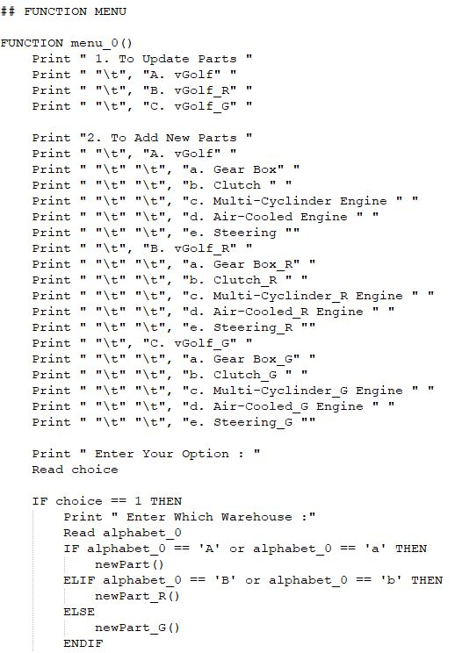

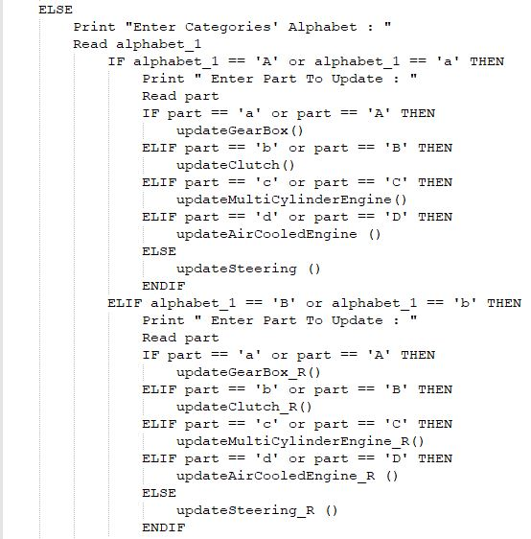

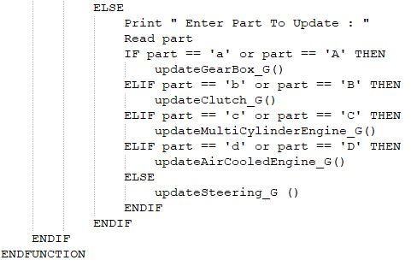

Figure 16

## Flow Chart

### Warehouses

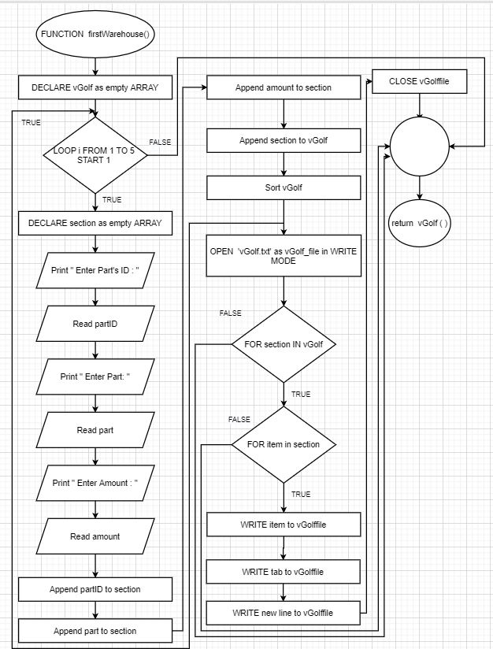

Figure 17

### Parts in respective section

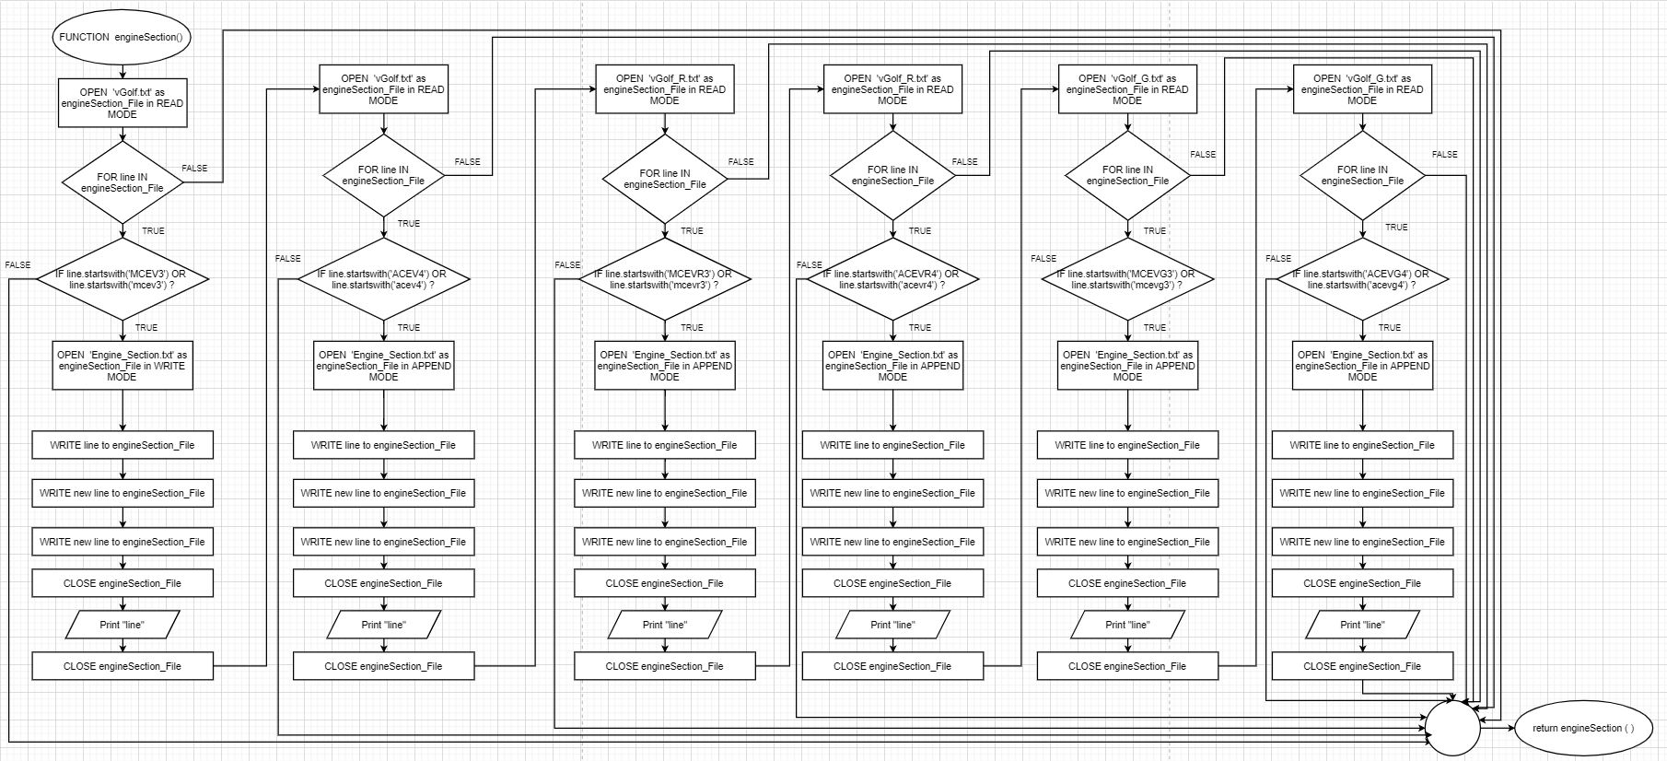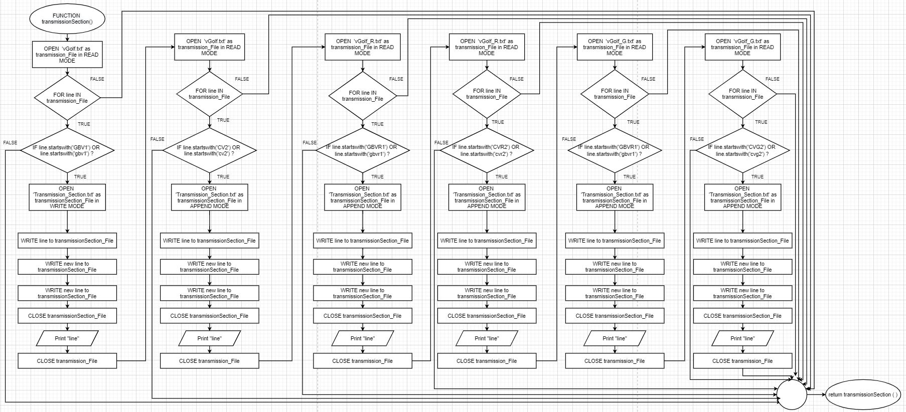

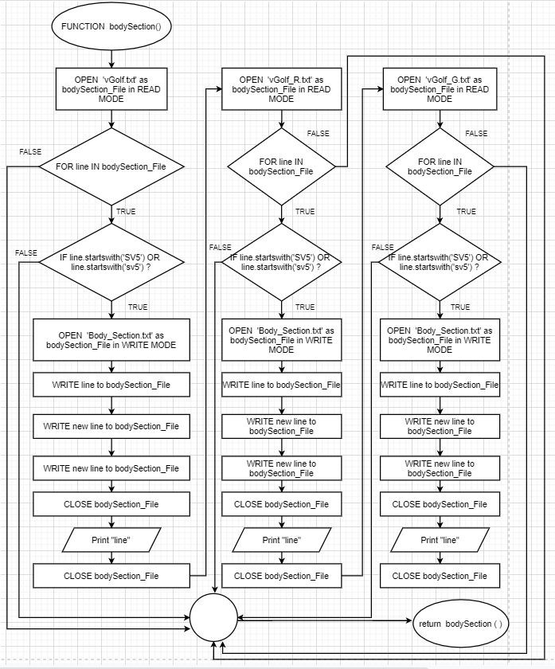

### 

Figure 18

### Update Parts’ Amount

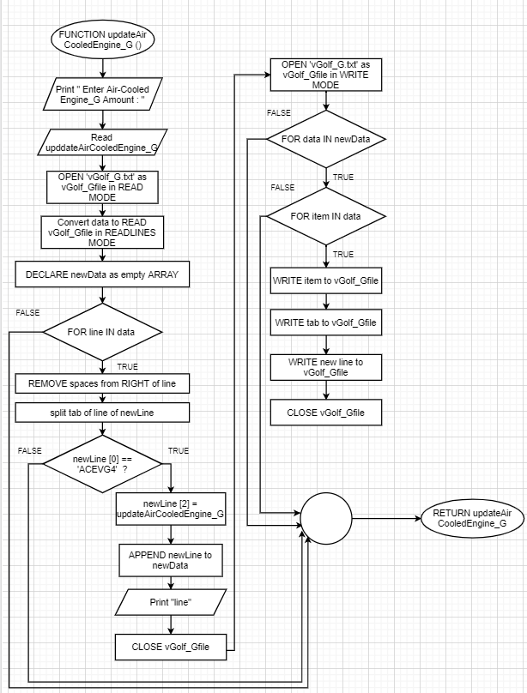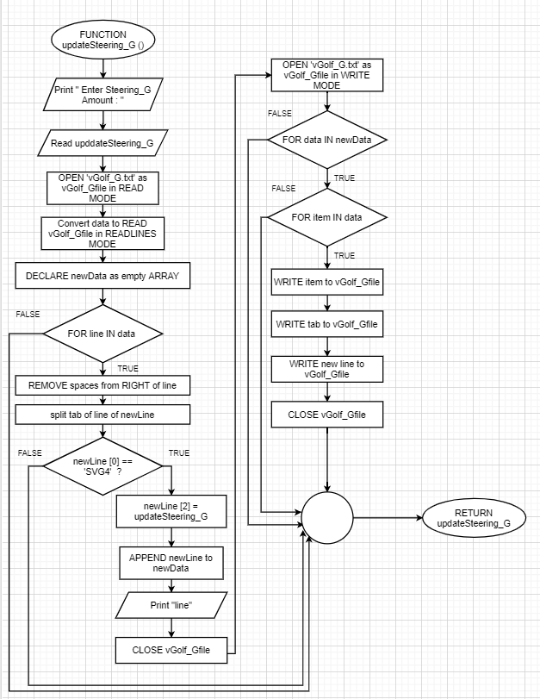

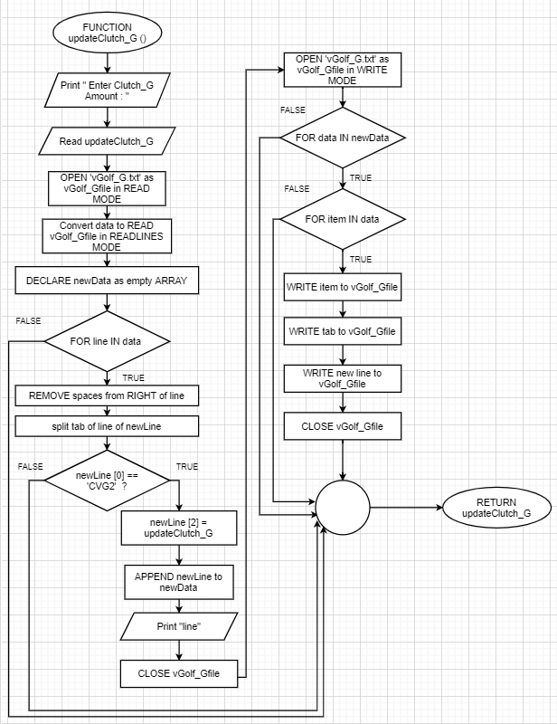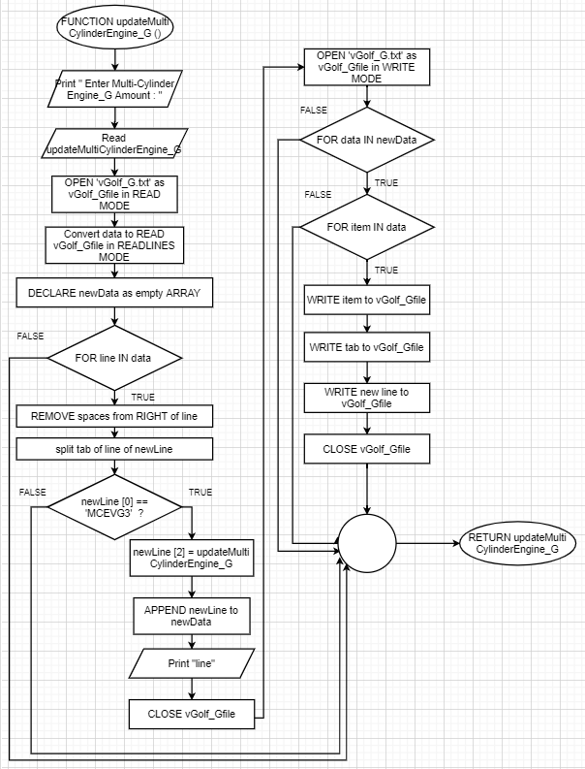

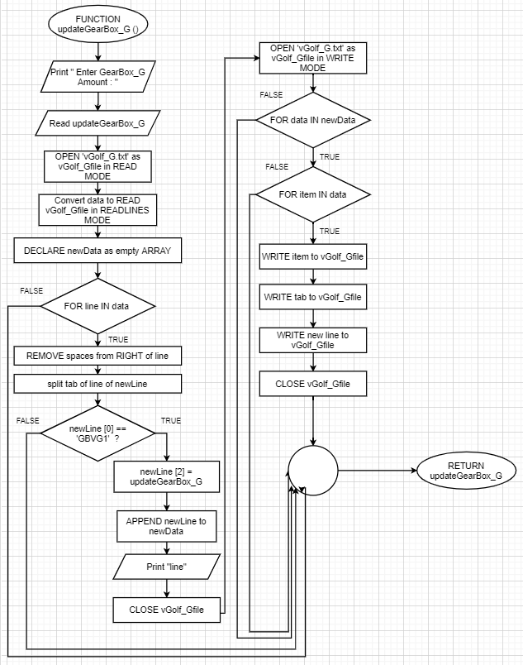

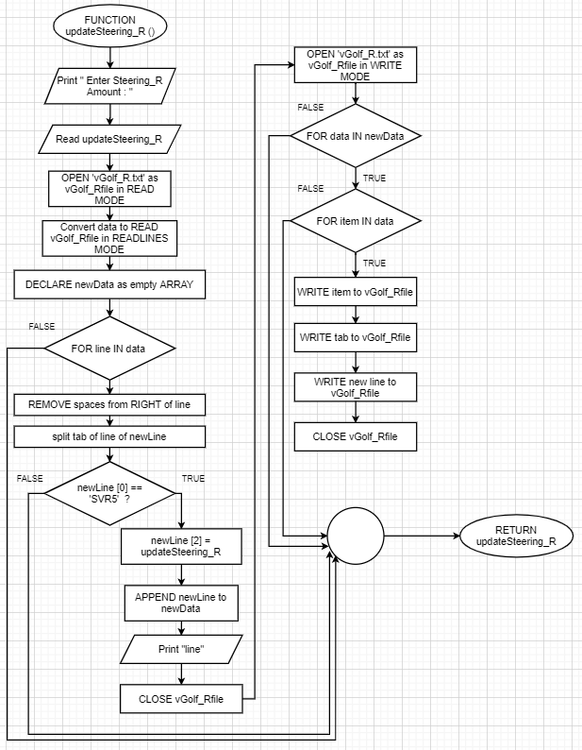

Figure 19

Figure 20

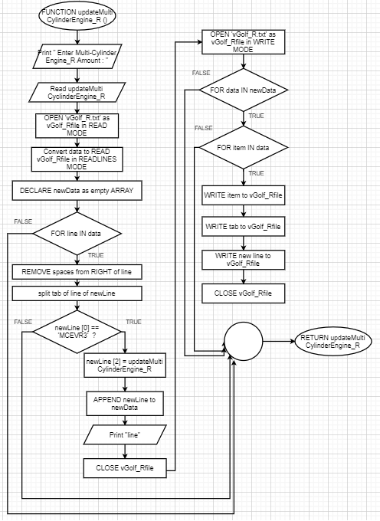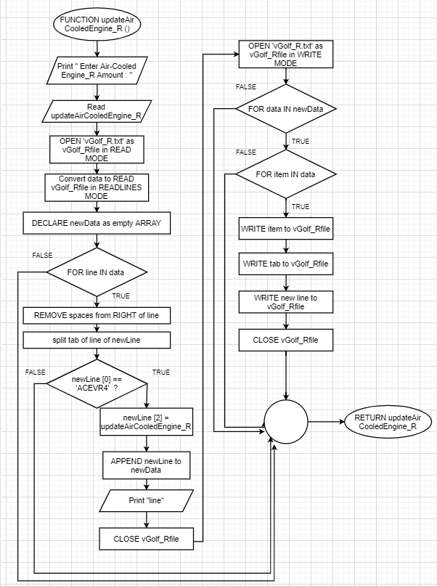

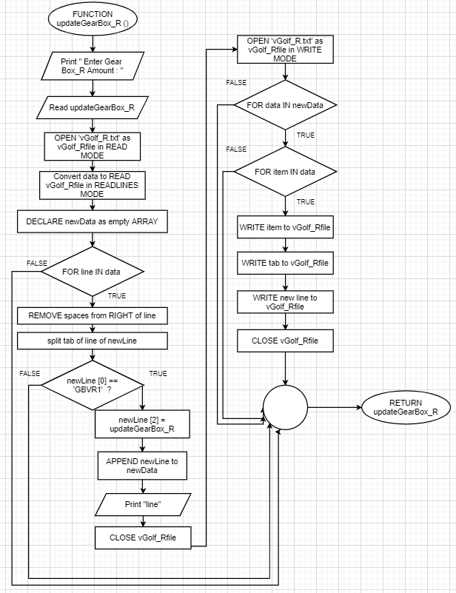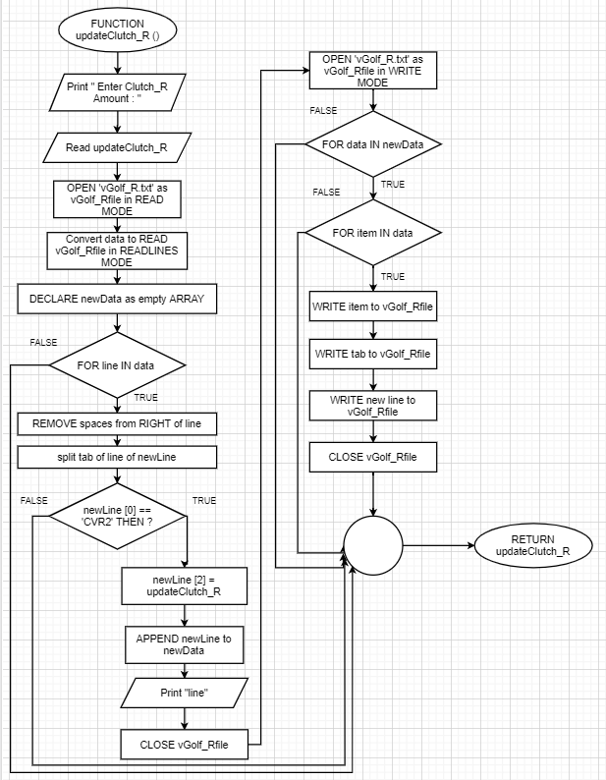

Figure 21

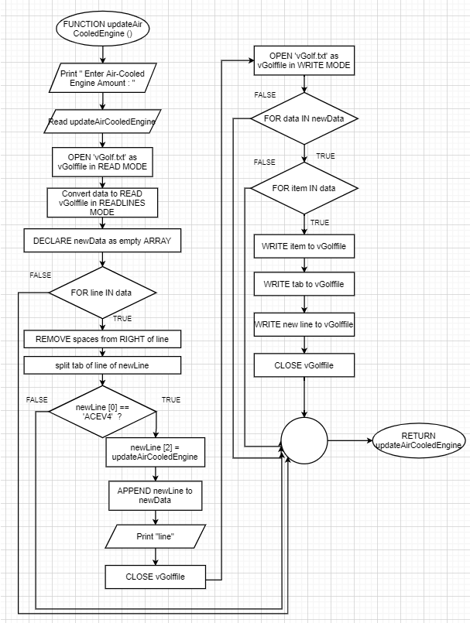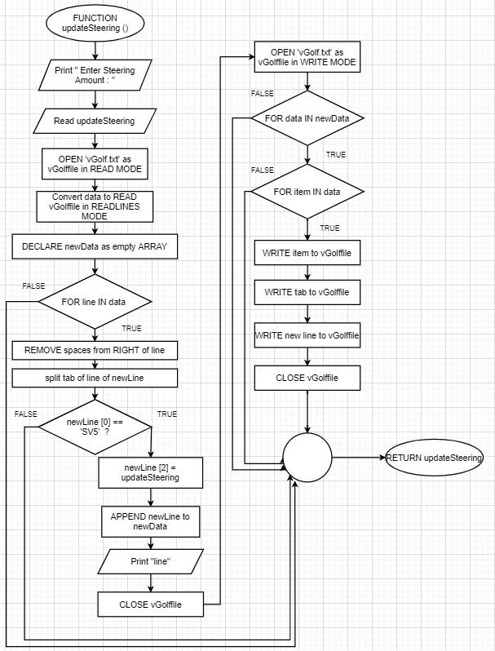

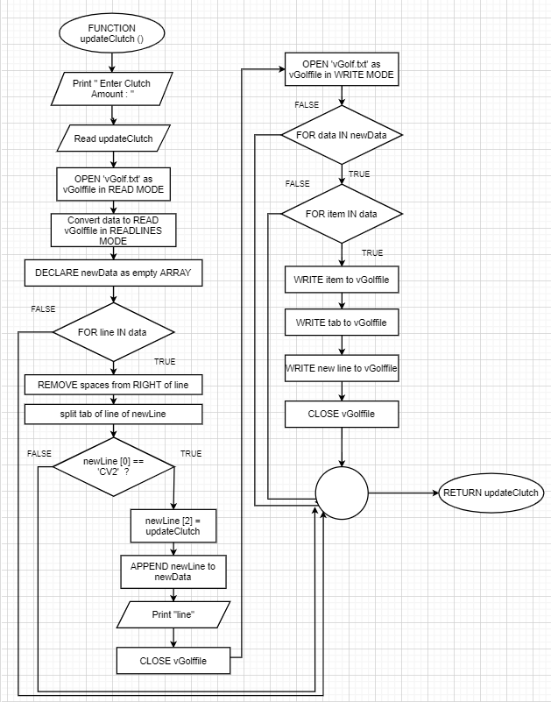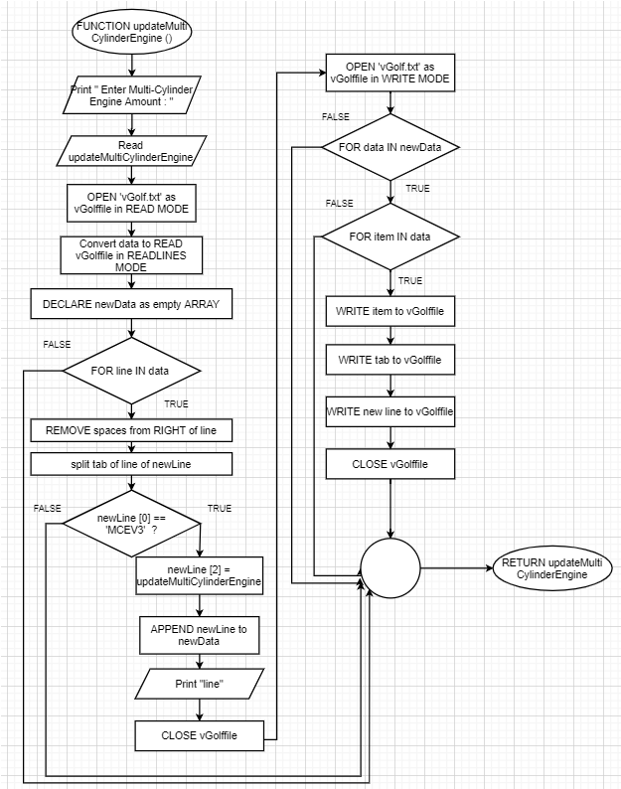

Figure 21

Figure 22

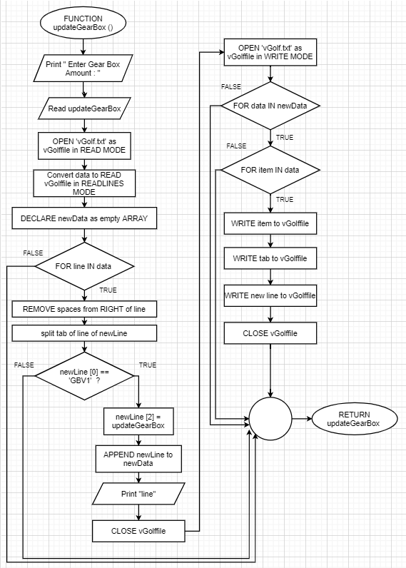

Figure 23

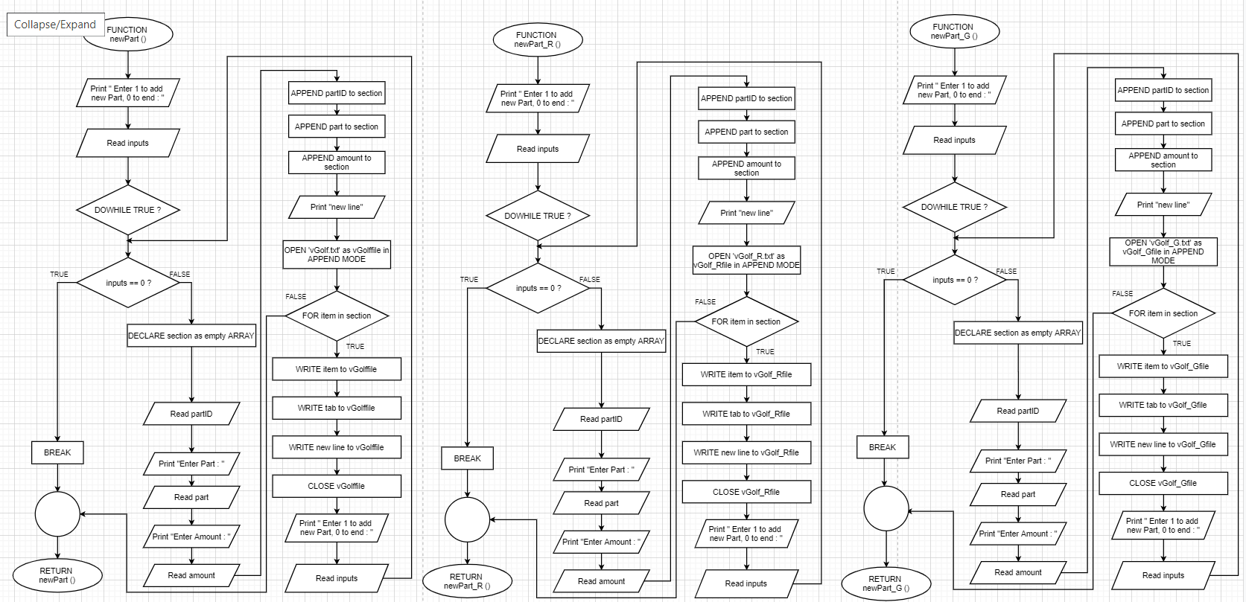

Figure 24

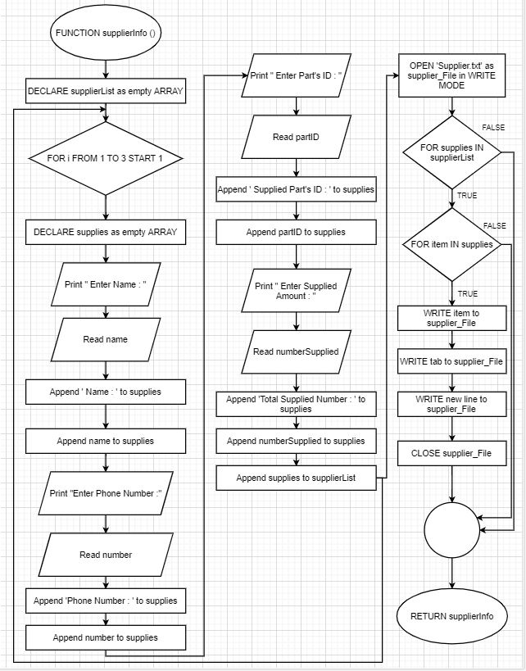Supplier Information

Figure 25

### 

### Record Supplier Supplied More Than One Part

Figure 26

### Print Warehouse Records

### 

### 

Figure 27

### Print items that are below 10

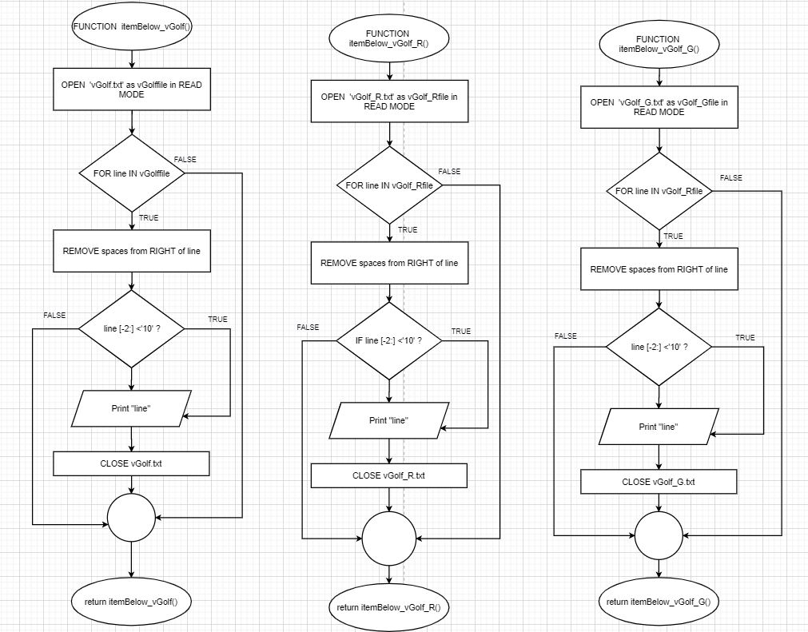

Figure 28

### Print Section’s Parts & Amount

### 

### Search Function

Figure 29

### 

Figure 30

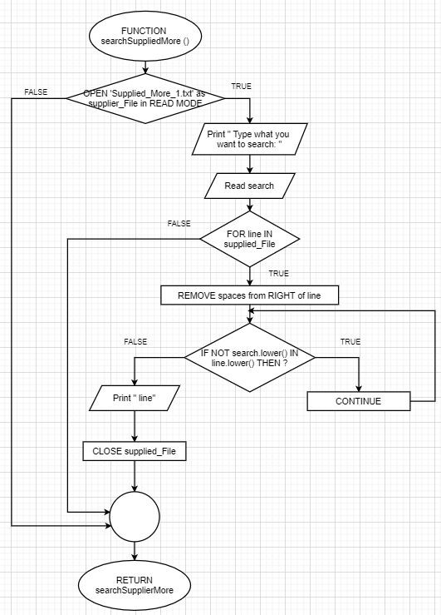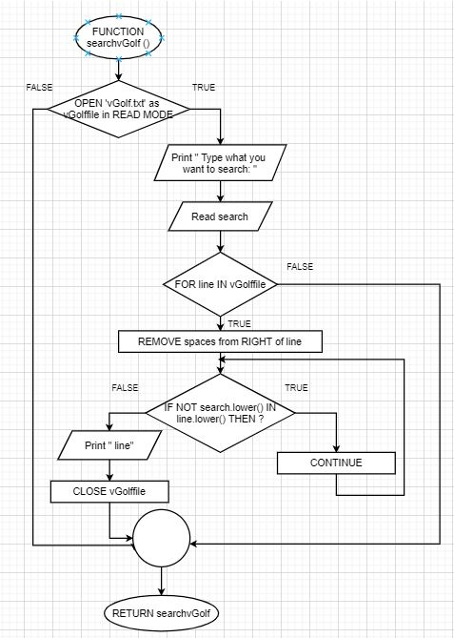

### 

Figure 31

menu Function Flowchart

Figure 32

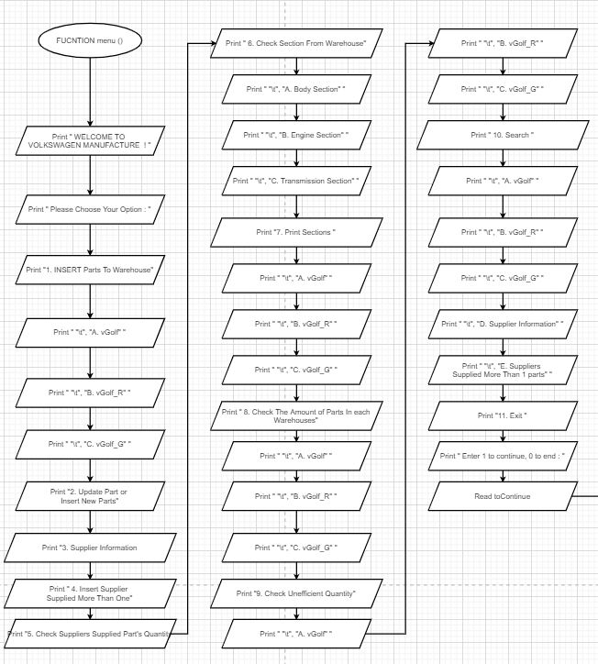

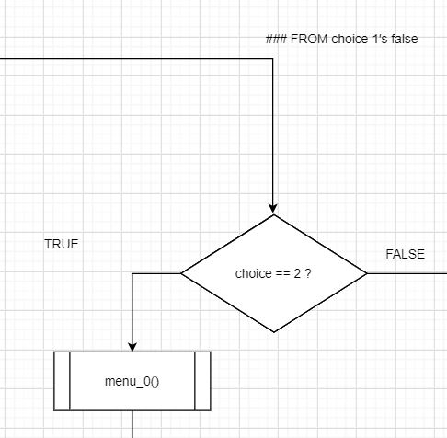

Figure 33

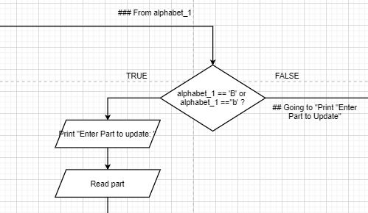

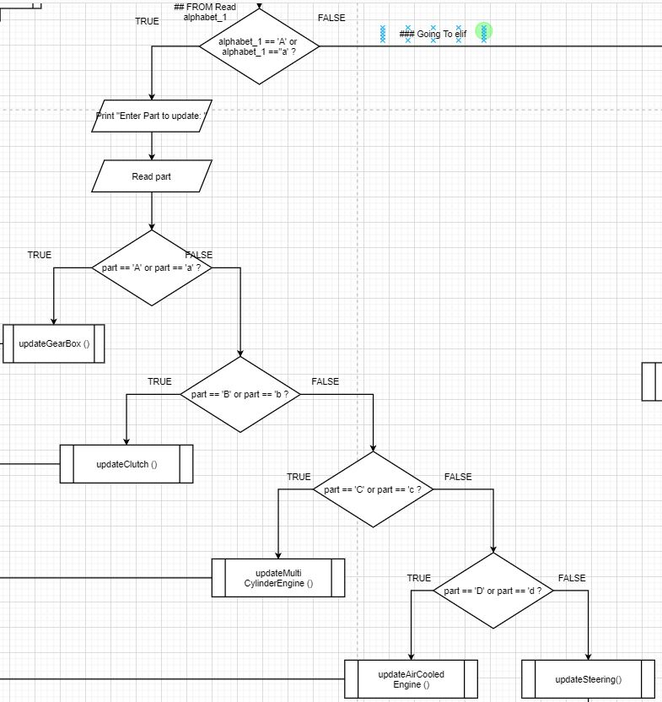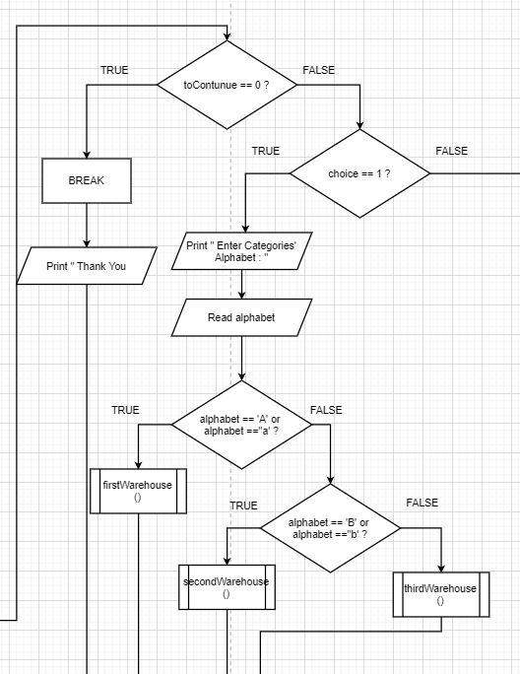

Figure 34

## TO part == ‘A’ or part == ‘a’

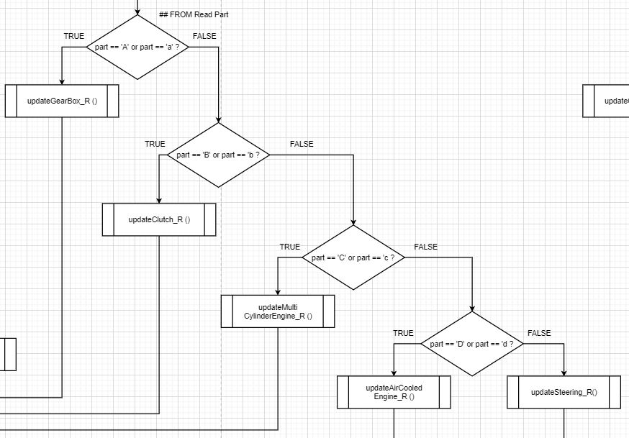

Figure 35

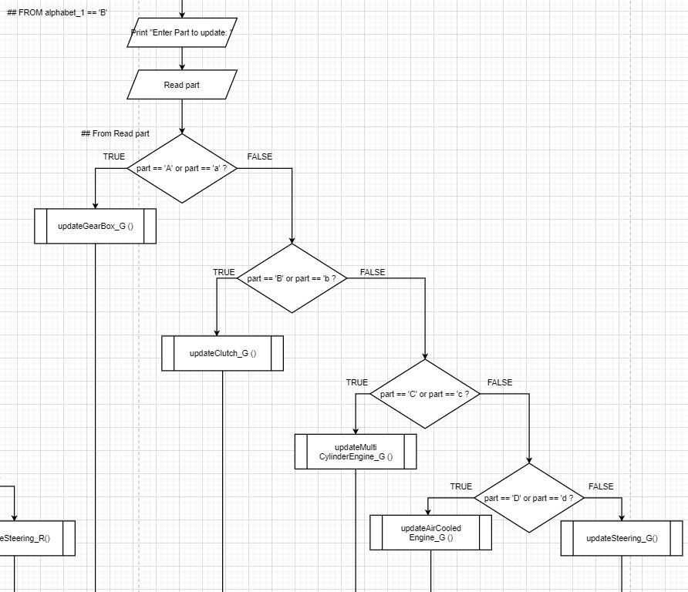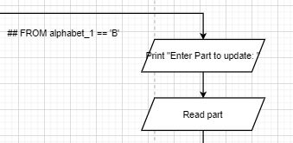

Figure 36

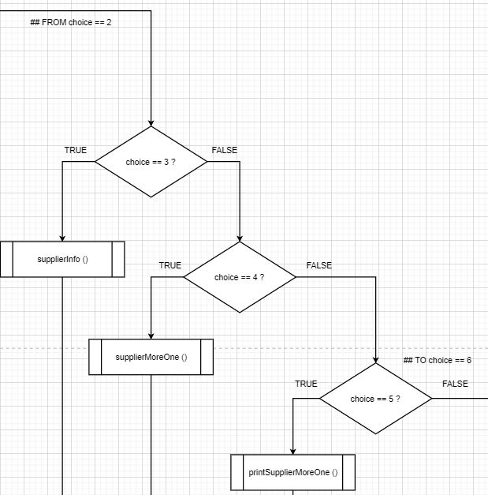

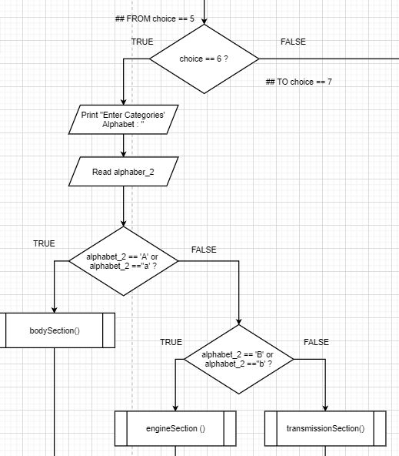

Figure 37

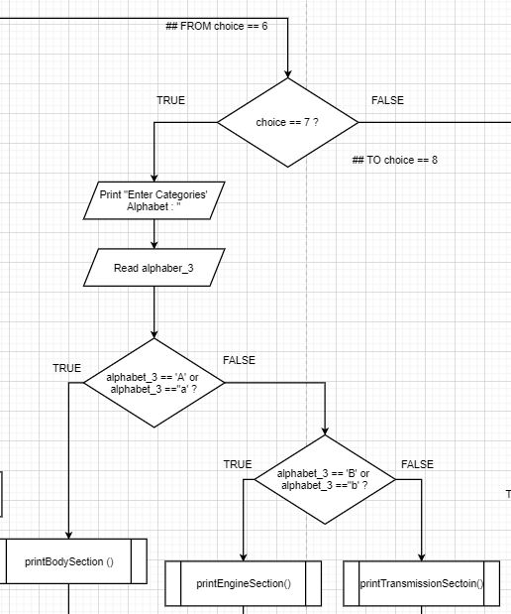

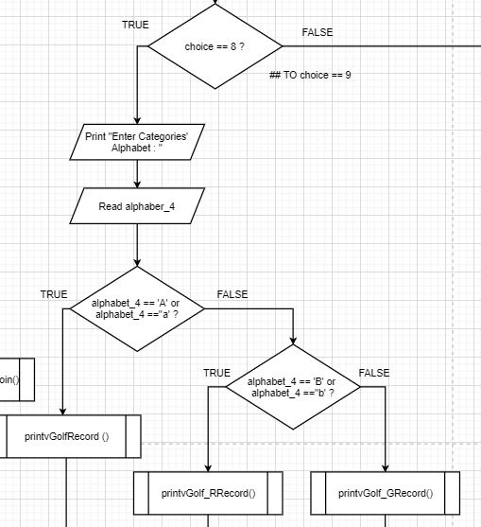

Figure 38

### From choice == 7

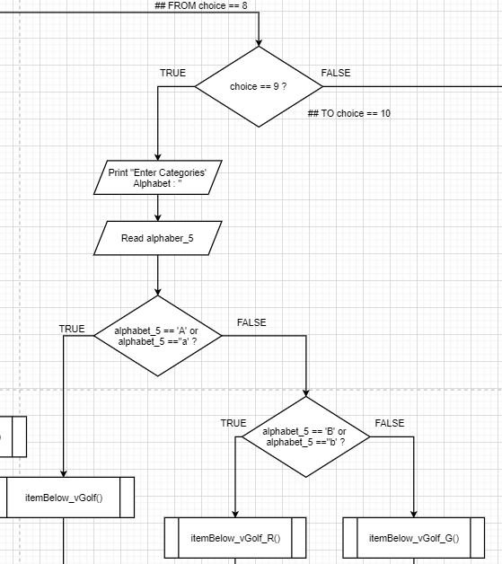

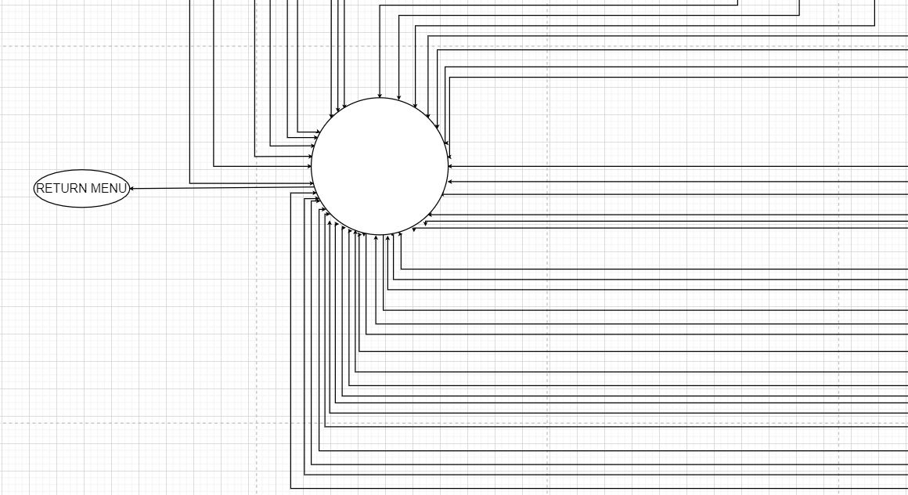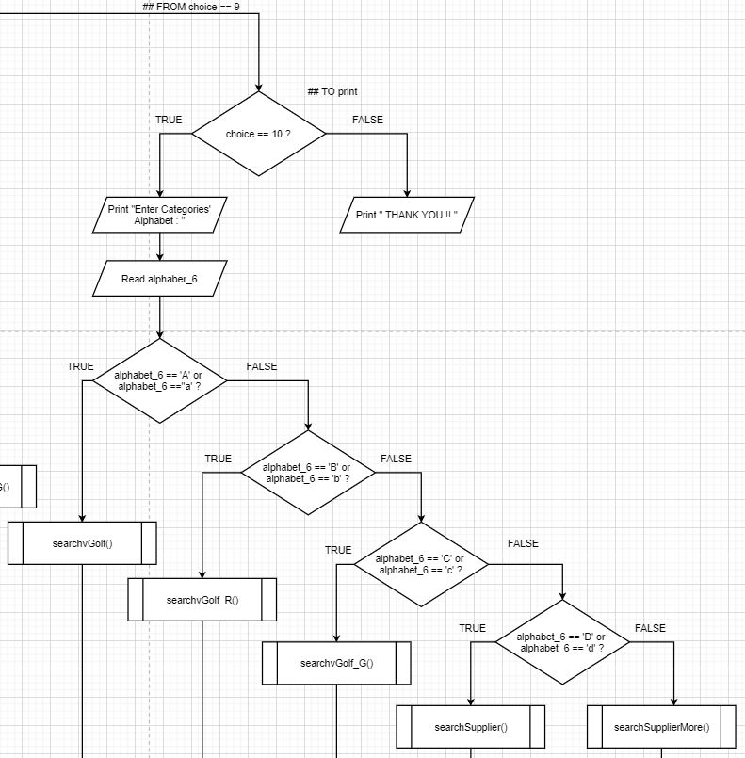

Figure 39

### FROM every function symbol

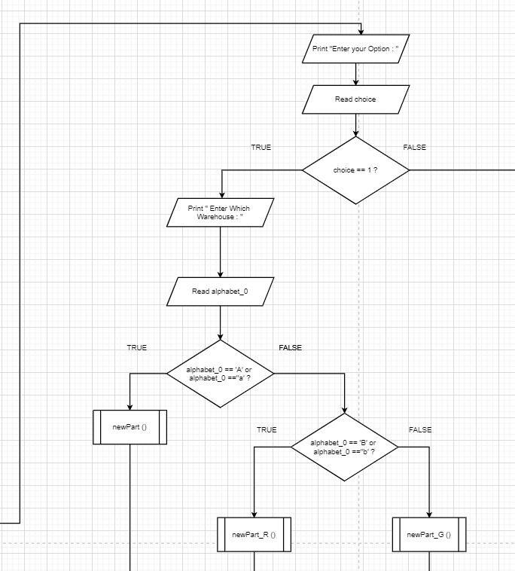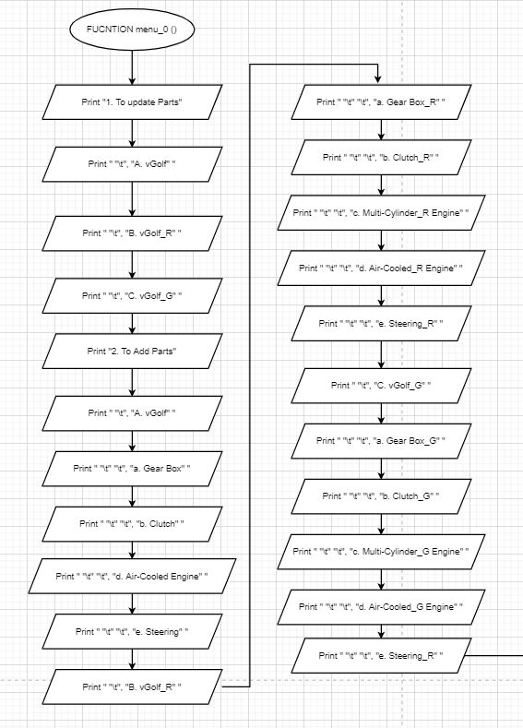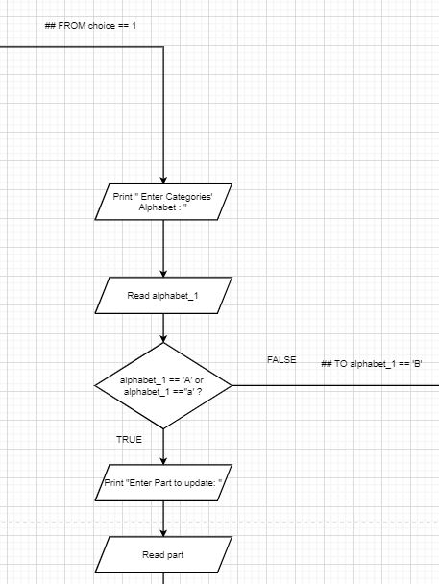

### 

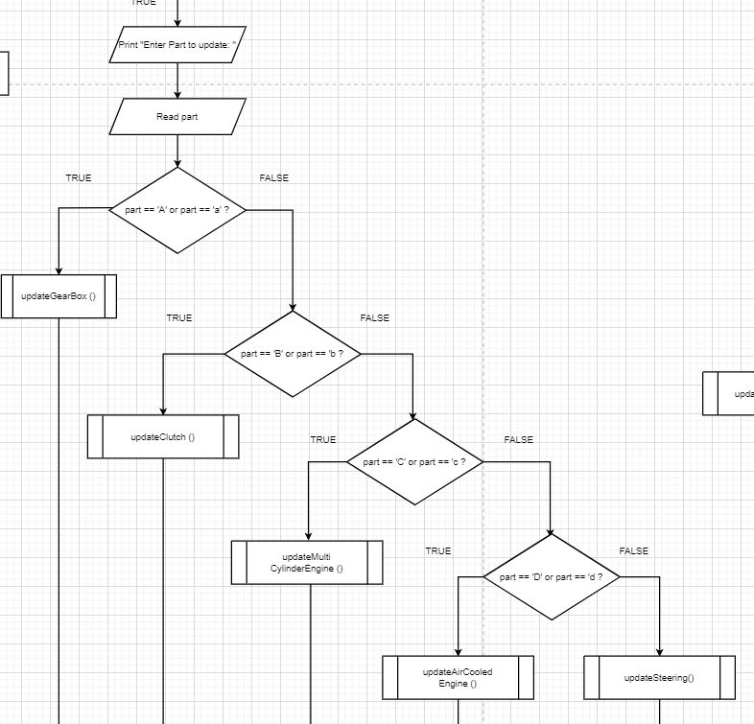

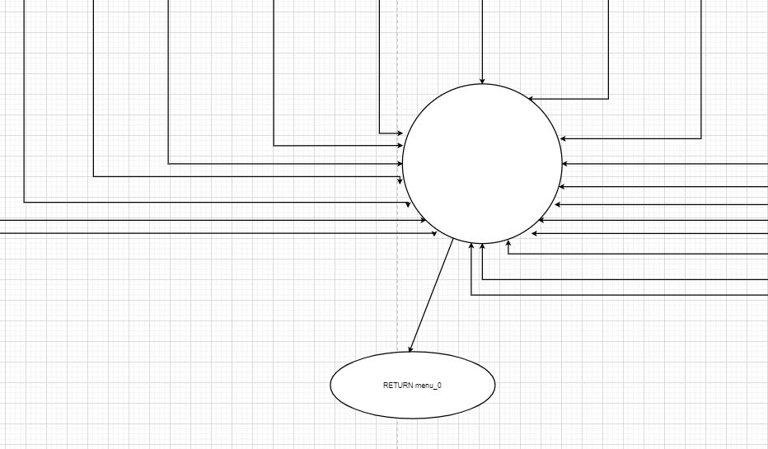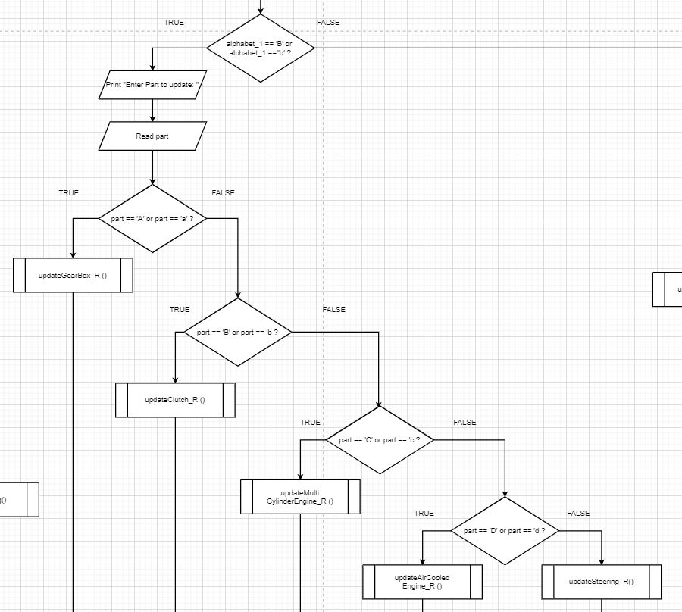

### FROM every function symbol

# Program Source Code Explanation

Firstly, record all the parts that have been collected into each respective warehouse which are shown in the three pictures under Warehouse in pseudocode. The three warehouses’ pseudocode and flowchart representing vGolf, vGolf_R and vGolf_G. As there are only five main parts in each warehouse, a FOR loop is used to record five times of part with respective ID and amount that had collected. To record it in as an ascending order, each list is sorted after appending. All the part is recoded in a list named section and stored in another list named vGolf, vGolf_R and vGolf_G in each warehouse as a bigger list. Then, each of the items are stored in different text file named vGolf text file, vGolf_R text file and vGolf_G text file. For the section as if in the bigger list and for item as if inside the section will then write the inputs into text files. However, text file must be closed after finished recorded. Thus, warehouses’ function are created.

To check if which item belongs to their section assembly and to record them to the text files, three functions are coded that shown under categorising parts to section. Each of the warehouses’ text file are opened in read mode to read the lines inside. Once read the line that starts with section’s part ID, the line will write into the sections’ text files which are Body_Section text file for Body Section, Engine_Section text file for Engine Section and Transmission_Section text file for Transmission Section. Besides, all section’s second line and following line are appended to the text file but write as write will rewrite the text file.

The pseudocodes in update part’s amount represents updating quantity amount after receiving from suppliers or decreasing after providing in warehouses. Users are requested to enter the part’s amount initially then respective warehouses text files are opened in read mode to read lines. To update a new input, an array is needed to write. The line in array will do remove the spaces from right of line and split the line with tab to update the input amount from user with IF condition. After that, warehouses’ text files are opened in writing mode to write the items in text file. To add any new parts after updating the amount, there is an option for users to choose if new parts needed to add. Therefore, an array is needed to record all the items and all of the item are appended to their own warehouses’ text file as recording.

As there are only three suppliers supplying parts to our manufacture, a FOR loop is used to record their information in a text file after the first array. The second array is opened to write and append the items in it. To store the items containing supplier information, a text file named Supplier text file is opened in write mode to write items.

In addition, to record who has supplied more than one part, a function named supplierMoreOne is coded. To record as much supplied suppliers, a DOWHILE TRUE condition is used to keep recording until the user breaks. In term of recording, arrays are needed to keep the items inside as strings and append every input in a text file named supplied_more_1 text file in writing mode.

Printing and checking supplier and warehouses information, print function are shown under Print Warehouse Parts Record. First of all is to open the text files in read mode and remove the spaces from right to print the line showing all the information in the warehouses or supplier’s information. Moreover, using the same method to print out the section’s parts and amount and to identify which item is insufficient.

Search function are used to search information. A try and except condition is used as if text file does not exist will quit the program. After insert search input the program will check if the inputs were matched with line. Once false, the program will keep continue until it matched with printing the line as an output.

# Screen Shot of input and output

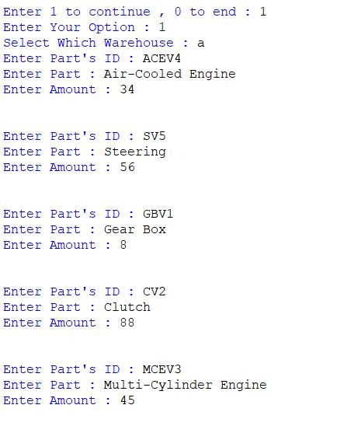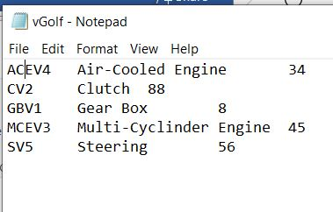

## 

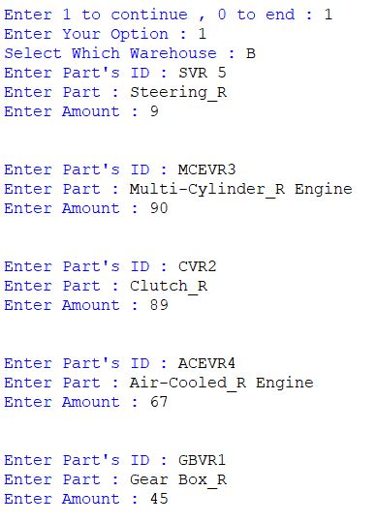

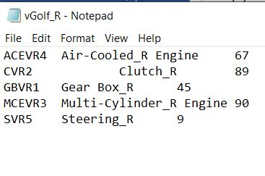

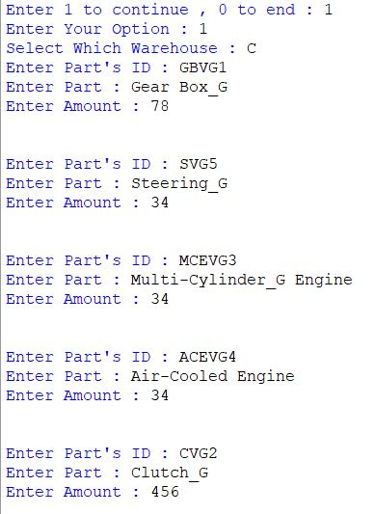

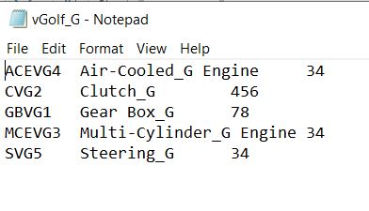

Figure 40

Picture above shows part’s ID, part name and amount of three warehouses and the input.

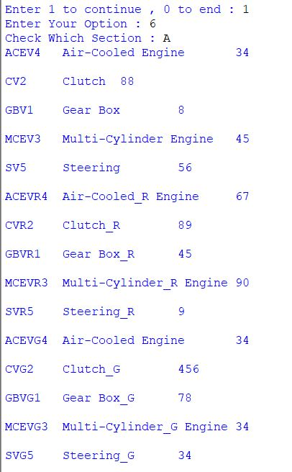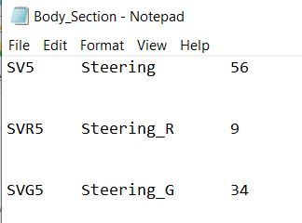

The pictures above show all the parts that belonging to body section from three warehouses.

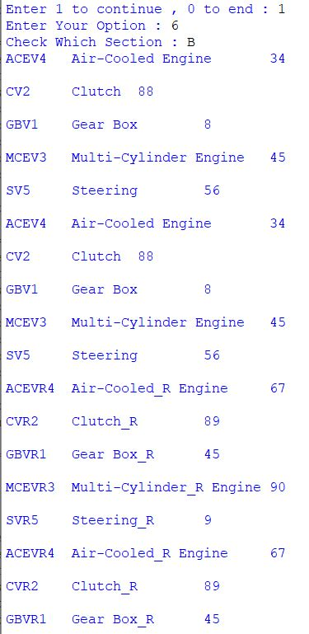

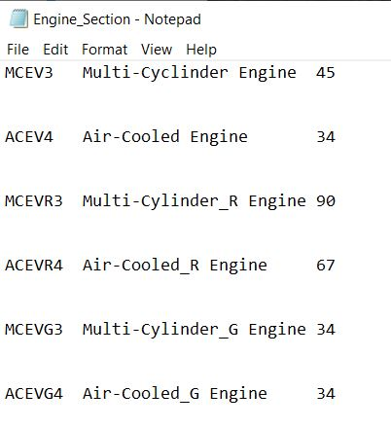

Figure 41

Figure 41 shows the output and input of the engine section.

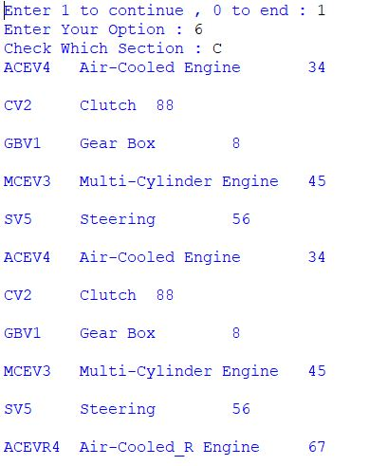

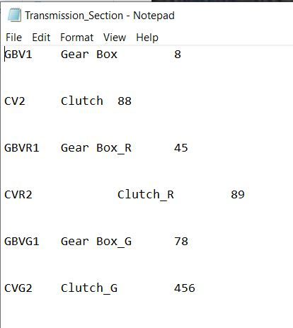

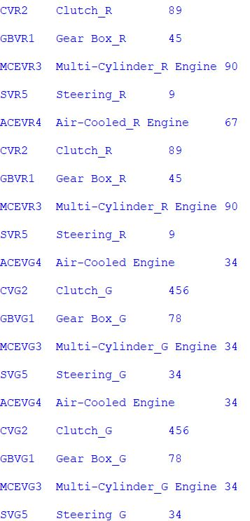

Figure 42

Above pictures show the parts recording to the transmission section and the output is shown on the right.

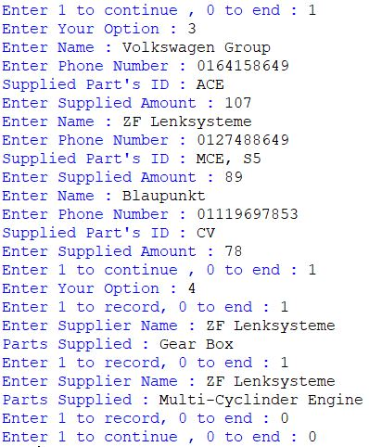

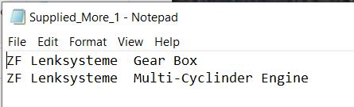

Figure 43

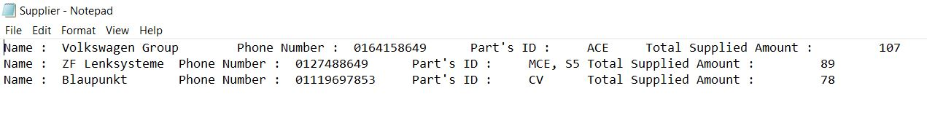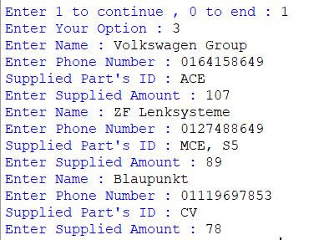In Figure 43, there is a function of representing inserting supplier who supplies more than a part and showed in text file.

Figure 44

Figure 44 shows that the writing code of supplier information with a function named supplierInfo showing all the output in the text file on the right of it.

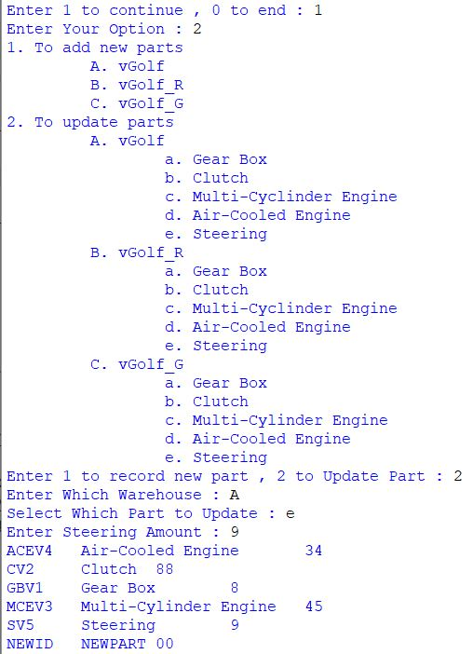

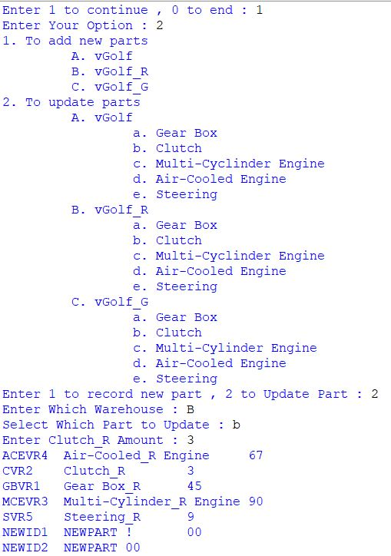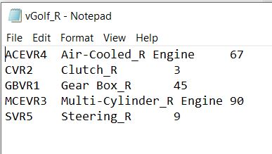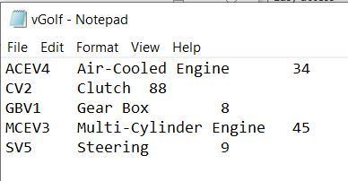

Figure 45

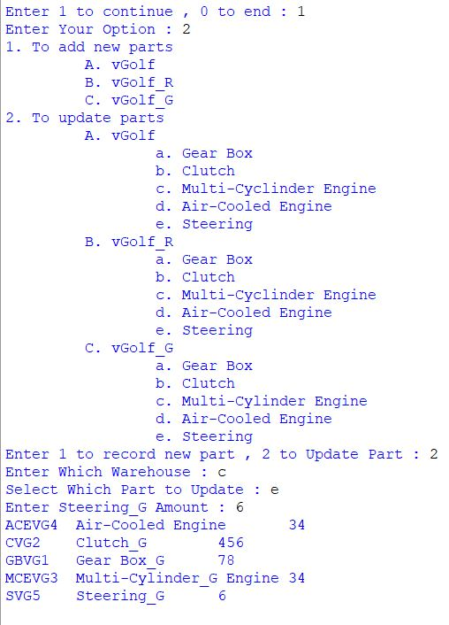

Figure 46

Figure 45 and 46 show one of the updated parts in each ware houses.

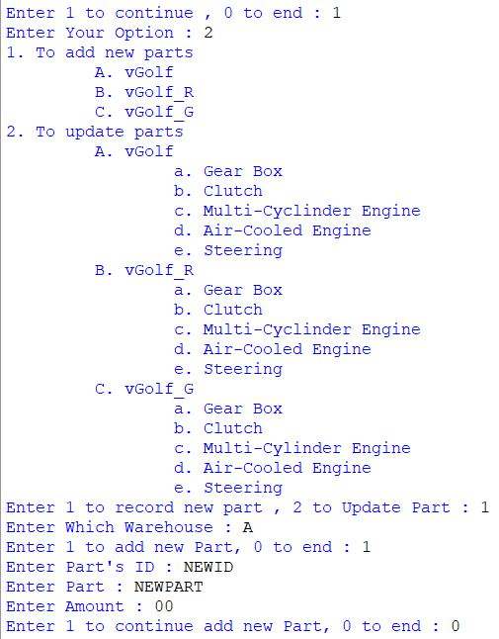

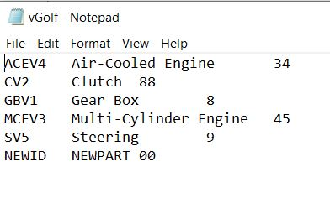

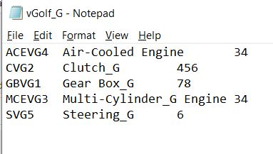

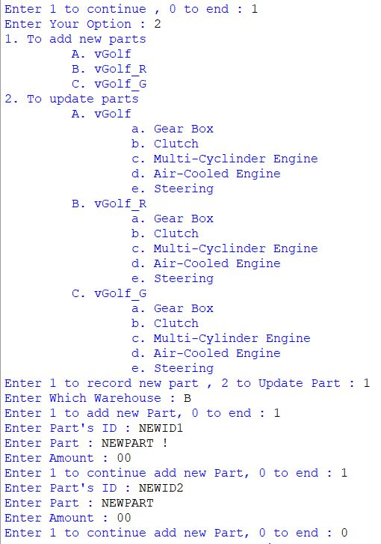

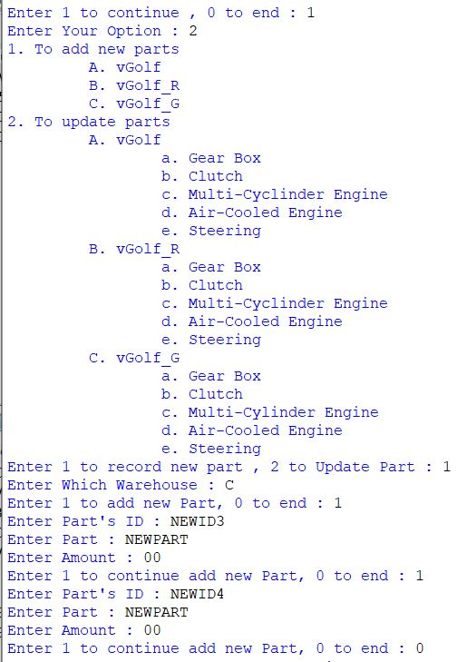

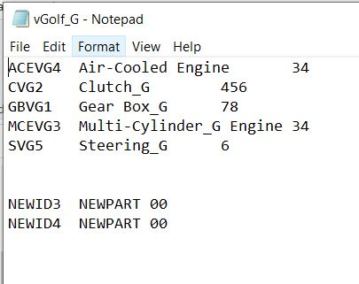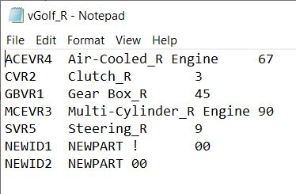Pictures above shows adding new parts into each ware houses.

Figure 47

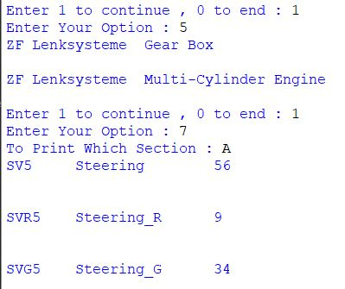

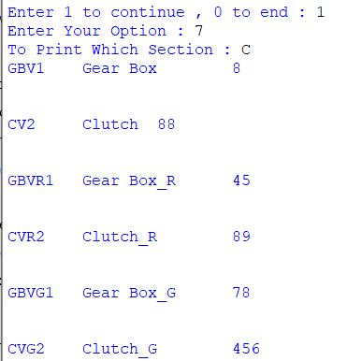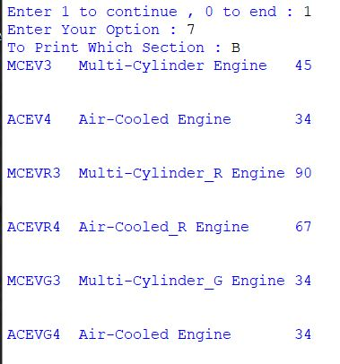

Figure 48

These pictures show to check the amount and part in each section. The ‘To print which section’ is mentioning which section to print.

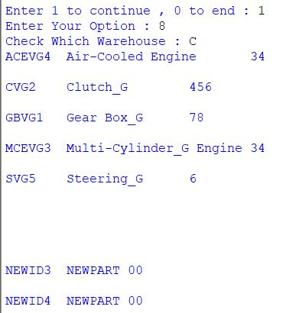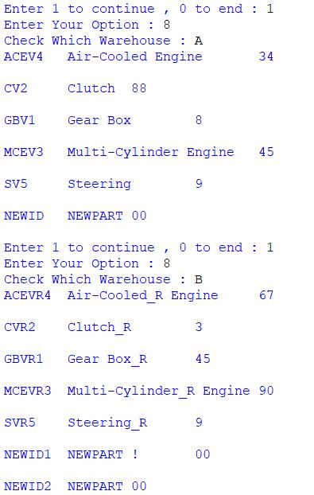

Figure 49 shows to check the total available quantity in each ware houses. Each line represents the line in each text file.

Figure 49

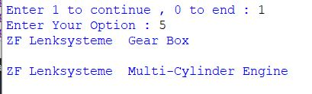

Figure 50

Figure 50 shows to print more than one part supplied by suppliers.

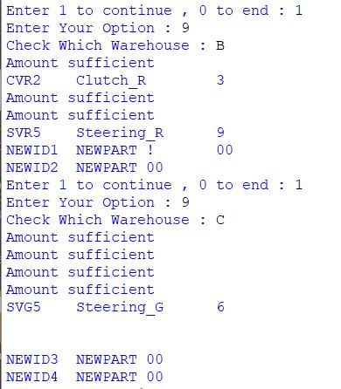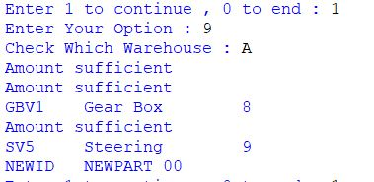

Figure 51

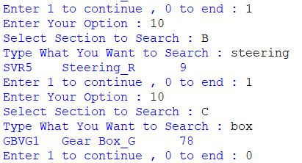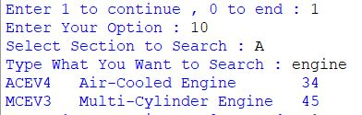Figure 51 show to check if the item is below 10 in each ware houses. All the alphabet in picture refers to warehouses. A is vGolf while B is vGolf_R and C is vGolf_G.

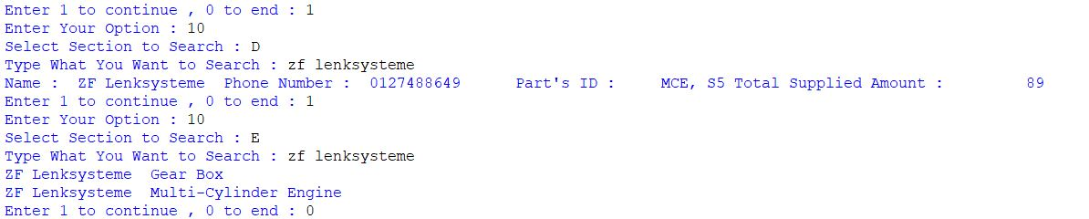

Figure 52

Pictures in figure 52 shows to search item from five text file ranging from A to E. A is vGolf text file, B is vGolf_R text file, C is vGolf_G text file while D is Supplier text file and the last is SupplierMoreOne text file showing who is supplying more than one part.

# Conclusion

Having this program to help recording all the information is undoubtedly helpful for the person-in-charge to refers instead of looking at the paper one by one consuming massive amount of time. Manufacturers are also able to check out all the possible output from this program by printing the information. Thus, manufacturers are able to recoding data and information efficiency.

# References

Enrico , B. (2018). *colswagennewsroom*. Retrieved September 05, 2020, from https://www.volkswagen-newsroom.com/en/press-contacts